LWL-Sachsenkabel GmbH celebrates its 30th anniversary

Fiber optic specialist from Gornsdorf/Ore Mountains is one of the leading German manufacturers of fiber optic cabling systems

Since its foundation in 1991, LWL-Sachsenkabel GmbH has developed into one of the largest specialists for fiber optic outfitting in Germany. The company offers high-quality and customized solutions for data centers, broadcast, FTTx, 5G and specialty optical fibers. On the 1^{s t} of July 2021 Sachsenkabel celebrated its 30th anniversary together with customers and business partners in a digital live event.

Gornsdorf/Ore Mountains, 07/ 06/2021 – LWL-Sachsenkabel GmbH celebrates its 30th anniversary this year. Founded in 1991, the company from Gornsdorf / Ore Mountains is today one of the leading German manufacturers of fiber optic cabling systems and employs more than 170 people at its Saxon company and production site. If initially the focus was on standardized cabling solutions for the telecommunications sector, Sachsenkabel today supplies customers from different areas such as data center, broadcast and FTTx. Most recently, the cable outfitter also expanded its portfolio to include fiber optic solutions for 5G and specialty optical fibers for industry, medicine and scientific research. Supported by the development of an internal product management as well as by a digital business team, the focus has shifted more and more towards individualized solutions in recent years. In addition to current product technologies, this also resulted in digital tools such as the smart service platform Sachsenkabel pulse, which supports customers in the configuration, ordering and quality control of individual cabling solutions.

The 2006 Football World Cup in Germany marked a milestone in the company's history: As a technology partner of a major network operator, Sachsenkabel received approval for a twelve-fiber fanout cable that was installed in the fiber optic network nodes of the World Cup host cities in order to be able to offer fast Internet to football-loving private customers. In other areas, too, the cable outfitter was amongst the technology forerunners: e.g., it was one of the first companies in Germany to master the challenging angled polishing of fiber front surfaces. Another important event in the company's history was the integration into the US-American Amphenol Corporation on February 23, 2021 – this merger means an expansion of the portfolio and an increase in international activities.

The 30-year success story of LWL-Sachsenkabel GmbH was celebrated with customers and business partners on 07/01/2021. Due to the pandemic situation, Sachsenkabel refrained from holding a face-to-face event and instead held the ceremony as a digital live event. On the occasion of the anniversary, the company donated an amount of 500 Euros each to a regional theatre association and a local children's and youth association. "We are extremely proud and happy that our digital anniversary celebration was so well received," emphasizes Silvia Duus, Managing Director at Sachsenkabel. "For me, this also reflects our close relationship with our customers and business partners, on which our success is ultimately based." The company is confident about the future and is looking forward to further successful business years.

Picture 1: Excerpt from the live event. f.l.t.r.: Philipp Richter (Moderator and actor), Silvia Duus (Managing Director), Lars Schumann (Sales Manager). ©LWL-Sachsenkabel GmbH

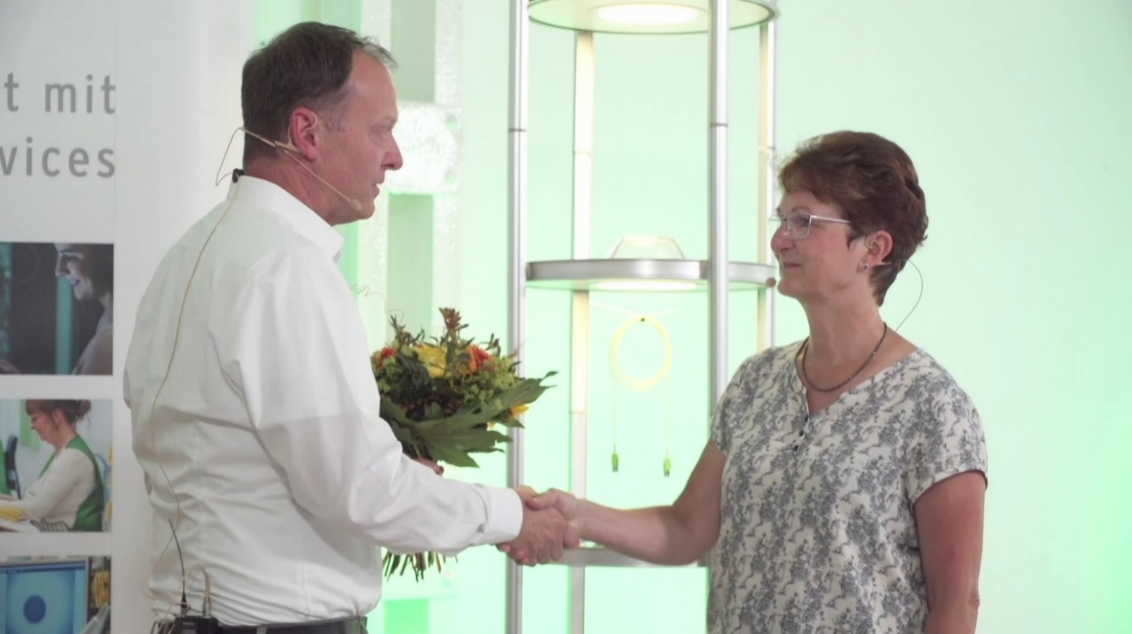
Picture 2: Congratulations to the Managing Director Silvia Duus on behalf of all employees. All participants tested negative for the coronavirus in advance. ©LWL-Sachsenkabel GmbH

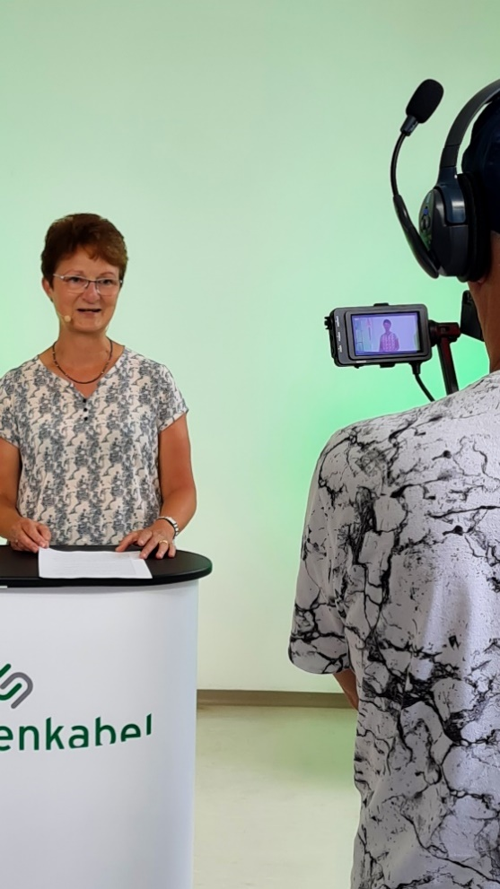
Picture 3: Silvia Duus, Managing Director of LWL-Sachsenkabel GmbH. ©LWL-Sachsenkabel GmbH

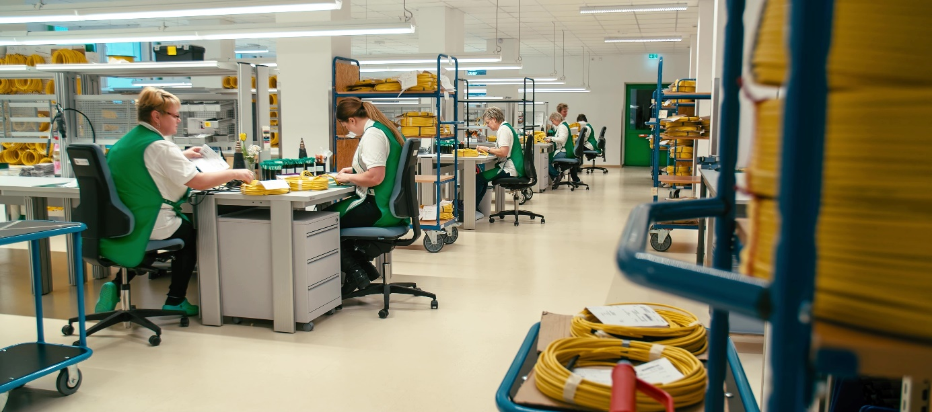
Picture 4: The manufacturing of the LWL-Sachsenkabel GmbH in Gornsdorf/ Ore Mountains. ©LWL-Sachsenkabel GmbH

About Sachsenkabel
LWL-Sachsenkabel GmbH located in Gornsdorf / Ore mountains, was founded in 1991. It is a subsidiary of Amphenol Corporation and one of the leading German manufacturers of fiber optic cabling systems. The focus of the business activities are fiber optic solutions for telecommunications, broadband development, data center, industry and broadcast as well as specialty fibers for demanding laser and spectroscopic applications. Sachsenkabel stands for high-quality and technologically pioneering solutions and has developed into one of the largest specialists for fiber optic assembly in Germany. The high capacity of plug assemblies per day enables flexible and fast realization of customer-specific requirements. Firmly integrated into the economic region of Chemnitz, the company today has a team of more than 170 highly qualified employees and supplies customers at home and abroad.

