**Press Release**

**Laser drying of electrode coating in lithium-ion batteries:**

**IDEEL research project aims to scale up process for the very first time to industrial production speeds**

**Laser-based drying replaces convection dryers and**

**thus supports more climate-friendly and economical production processes**

*The IDEEL research project, supported by the German Federal Ministry of Education and Research (BMBF) as part of the Battery 2020 funding program, aims to launch a laser drying process for a more climate-friendly and economical series production of lithium-ion batteries. The results will be incorporated into the Fraunhofer Forschungsfertigung Batteriezelle (battery cell research production facility) in Münster, Germany, which will enable users from both industry and research to test and optimize the series production of new batteries.*

**Mülheim-Kärlich, November 23, 2021** - To develop an industry-relevant laser drying process that supports a more climate-friendly and economical series production of lithium-ion batteries. With this goal in mind, the publicly funded research project IDEEL (Implementation of Laser Drying Processes for Economical & Ecological Lithium-Ion Battery Production) was launched on October 22, 2021. The project is designed to run for three years, culminating in the development of an exemplary laser drying system that will demonstrate a near-production drying of the electrode coating in high-performance batteries. The planned system will take up less production space, and will also operate faster and be more energy-efficient than conventional drying technologies*. This project is conducted by the following research partners:

* Laserline GmbH
* Coatema Coating Machinery GmbH
* Optris GmbH
* Fraunhofer Institute for Laser Technology (ILT)
* Forschungsfertigung Batteriezelle (FFB) at the Fraunhofer Institute for Production Technology (IPT)
* Münster Electrochemical Energy Technology (MEET), Battery Research Center / Batterieforschungszentrum der Westfälischen Wilhelms-Universität Münster (WWU University)
* Production Engineering of E-Mobility Components (PEM) of the Rheinisch-Westfälische Technische Hochschule Aachen (RWTH University)

Within the IDEEL initiative, the project partners are pursuing several sub-goals. In the first phase, a new electrode slurry optimized for laser use is being developed as a coating material (PEM RWTH, MEET WWU), a highly efficient laser system with a large-area, homogeneous laser spot (Laserline), and a highly integrative process monitoring system based on contactless temperature measurement (Optris, Laserline, Fraunhofer ILT). On this basis, the laser-based drying process is to be scaled up to industry-standard feed rates within a demonstrator (Coatema); and finally, the physical model of the new drying process is to be validated (ILT, FFB). The research project is supported by the German Federal Ministry of Education and Research (BMBF) as part of the Battery 2020 funding initiative.

In the future, the results of the IDEEL project will be incorporated into the processes of the Fraunhofer Forschungsfertigung Batteriezelle (FFB), which is supporting the project in a conceptual and advisory capacity. The FFB is considered one of the leading projects in German battery research and it is, according to the wishes of its operators and sponsors, to be formed into a development center of modern battery cell production for Germany and its European partners. A complete production infrastructure is therefore currently being built at the Münster site, which will enable companies and research institutions to test and optimize the series production of new batteries. The goal is to enable efficient, low-cost and high-quality battery production that significantly and permanently reduces German and European producers’ dependence on the global market. The German Federal Ministry of Education and Research (BMBF) and the state of North Rhine-Westphalia are funding the establishment of this research production facility with a sum of up to 680 million euros.

|  |
| --- |
| **IDEEL Project:**  The research project "IDEEL" is funded as part of the BMBF program Batterie2020 by the Federal Ministry of Education and Research (BMBF) under the funding code 03XP0414A through the project management organisation Project Management Jülich (Forschungszentrum Jülich GmbH).  The project partners are Laserline GmbH, Coatema Coating Machinery GmbH and Optris GmbH, as well as the Fraunhofer Institute for Laser Technology (ILT), the Fraunhofer Research Institution for Battery Cell Production (FFB), the Münster Electrochemical Energy Technology (MEET) Battery Research Center at the University of Münster and the Production Engineering of E-Mobility Components (PEM) at RWTH Aachen University. The aim of the three-year project is to develop an industry-relevant laser drying process that will enable series production of lithium-ion batteries that is both more climate-friendly and economical.  Initially, a new electrode paste optimized for laser use will be developed as a coating material (PEM, MEET), a highly efficient laser system with a large-area, homogeneous spot (Laserline) and a highly integrative thermographic camera for contactless process monitoring (Optris, Laserline, Fraunhofer ILT). Based on these contributions, the laser-based drying process will be scaled up to industry-typical feed rates within a demonstrator (Coatema) and the physics-based model of the new drying process subsequently validated (ILT, FFB).  The research results are to be incorporated into the FFB's processes in the future. The work of the FFB is considered one of the flagship projects of German battery research and is expected to become the principle development center of modern battery cell production for both Germany and European partners, with the goal of reducing German and European manufacturing dependence on the world market. A complete production infrastructure is therefore currently being built at the Münster site, with the intention of providing support to companies and research institutions seeking to test and optimize the series production of new battery designs. |

|  |
| --- |
| Laser drying in the context of battery production:The drying process addressed by the IDEEL project is part of the electrode manufacturing process for high-power battery cells, such as those used in electric vehicles and home storage systems. It is used to dry an electrode paste (slurry), which consists of a specially adjusted, homogeneous active material mixture and is applied to the copper foil of the battery electrode. Up to now, convection dryers have been used to dry this electrode coating, but the thermal energy transfer is only indirect into the material and thus places a heavy burden on both the CO2 balance and the energy costs of battery production. The IDEEL project partners are therefore focusing on up-scaling a more energy-efficient drying process in which the coating is irradiated using high-power diode lasers. The process benefits from the strong absorption of infrared laser light in the coating material, allows for more flexible and precise process control compared to common convection technology, and where the IDEEL project ultimately aims to demonstrate web speeds of up to 30 meters per minute. The compact design and efficient energy transfer are expected to significantly ease the extensive space requirements of the drying sections, which are typically more than 100 meters long – with a significantly reduced spatial footprint for the production environment, the planning of new production systems should enable faster and more energy-efficient process control. |

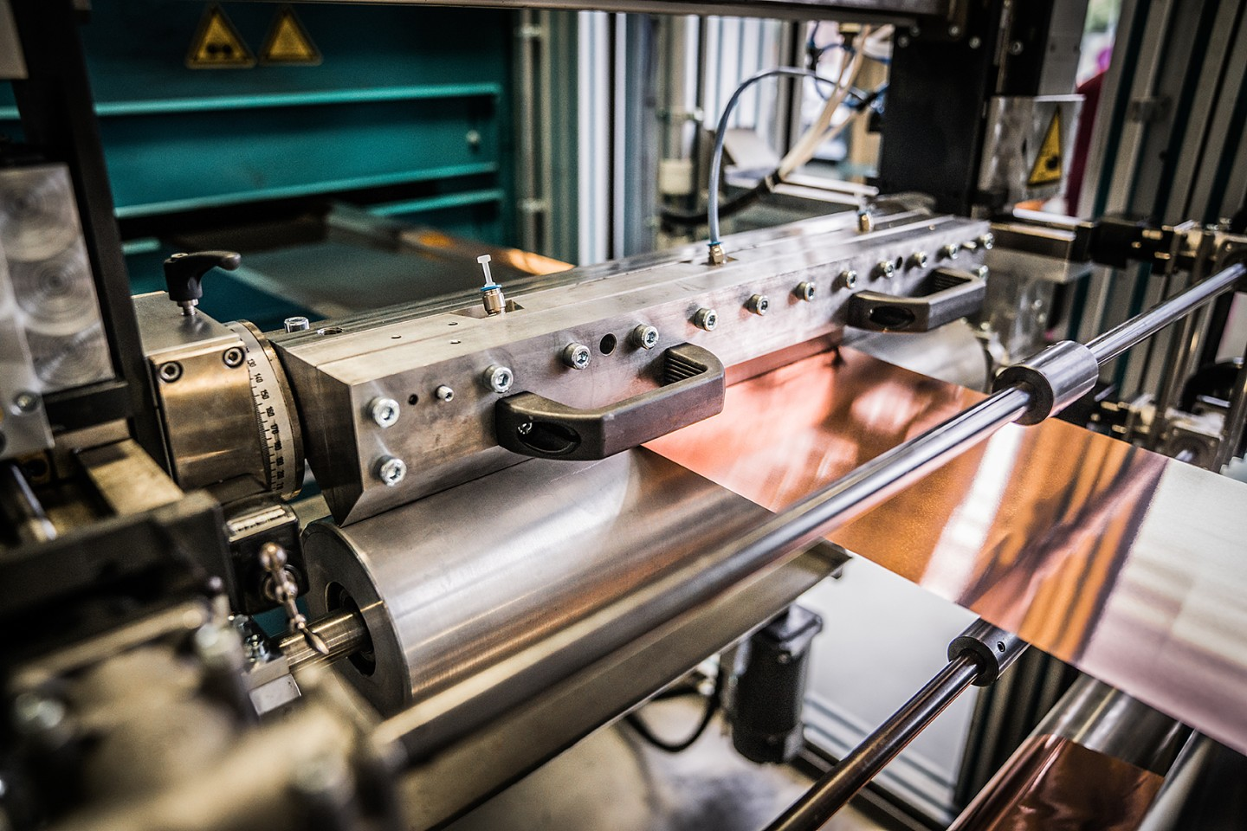

***Picture 1: The copper foil is continuously coated with an electrode slurry through a slot die***

***© Studio Wiegel / Fraunhofer***

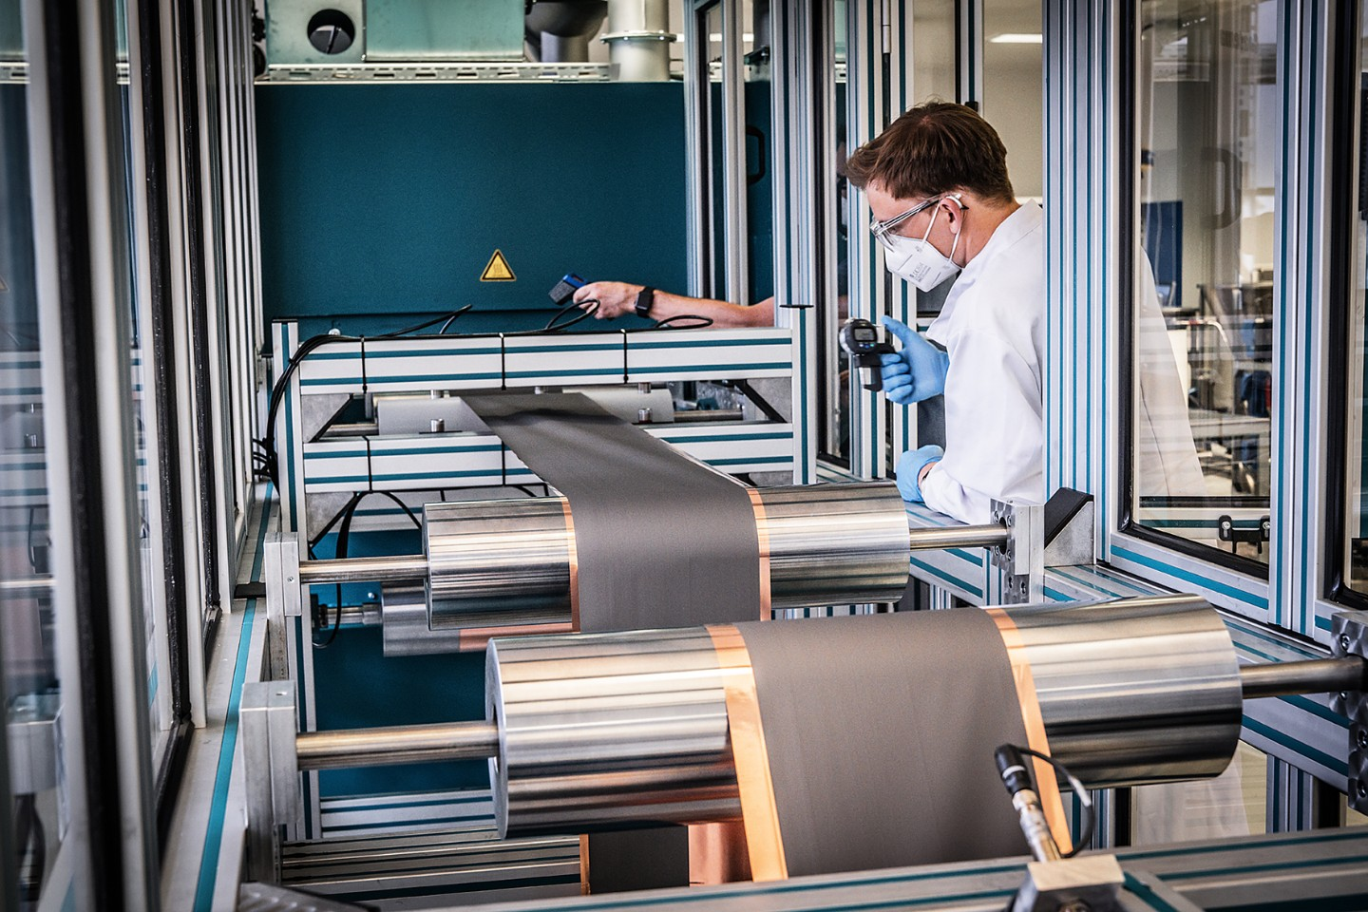 ***Picture 2: The coated foil (electrode) is submitted to a precise quality inspection and coiled***

***© Studio Wiegel / Fraunhofer***

**About Laserline:**

Laserline GmbH launched its business in 1997 in the German city of Mülheim-Kärlich (close to Koblenz). As a leading international manufacturer of diode lasers for industrial material processing, Laserline has since become the very embodiment of this innovative technology and can look back with pride at 20 years of corporate history. More than 5,000 high-power diode lasers from Laserline are currently in use worldwide and have proven their efficiency in a wide range of different processes and applications. Currently, the company employs about 340 people and has several international subsidiaries in the USA, Brazil, Japan, China, South Korea and India, as well as representatives in Europe (France, UK, Italy) and in the Asia-Pacific region (Australia, Taiwan). The company is also highly focused on sustainable growth, so that by setting up its headquarters in Mülheim-Kärlich, the spatial conditions for future expansion in terms of development and production were thus laid from the get-go. More information at <https://www.laserline.com/de-int/>

Within the context of the IDEEL project, Laserline is focusing on the development of a homogeneous and efficient laser system technology for large-area drying in electrode production. The starting point for the development work is the high-power diode lasers of the Laserline LDF series, which are destined for surface drying due to their extremely homogeneous energy input and millisecond-fast stepless power control. As part of the plan to launch a more climate-friendly and economical battery production, one of the most important project goals is to further increase the efficiency of the high-power diode laser, even as it claims the highest energy efficiency among all industrial lasers. Furthermore, to enable a high-precision process control, Laserline will develop special process optics based on its proven beam-shaping optics to enable integrative process monitoring.

|  |  |
| --- | --- |
| **Company contact:**  **Laserline GmbH**  Stefan Aust  Fraunhofer Straße  56218 Mülheim-Kärlich, Germany  Tel. +49 (0) 2630 964-1440  Fax +49 (0) 2630 964-1018  stefan.aust@laserline.com  www.laserline.com | **Contact agency:**  **Riba: BusinessTalk GmbH**  Michael Beyrau  Klostergut Besselich  56182 Urbar/Koblenz, Germany  Tel. +49 (0)261-963 757-27 Fax +49 (0)261-963 757-11 mbeyrau@riba.eu  www.riba.eu |