Sachsenkabel increases production capacity in specialty optical fibers for industry and science

New production facility enables expansion of special fiber range for laser applications, sensor technology and spectroscopy

LWL-Sachsenkabel GmbH has expanded its production capacity in the field of fiber optic solutions for industry and science. With the opening of a new production facility, the company is responding to the increasing demand for customized special products and expanding its product range of fiber optic solutions for laser and laboratory technology as well as medicine, spectroscopy, and sensor technology.

Gornsdorf/Erzgebirge, 29.03.2022 - LWL-Sachsenkabel GmbH, one of the leading German manufacturers of fiber optic cabling systems, has increased its production capacities in the field of special fibers for industry, medicine and scientific research with its new production facility. This is the company's response to the sharp rise in demand for customized fiber optic solutions for laser and laboratory technology applications as well as medicine, spectroscopy, and sensor technology.

The new, approx. 1000 m² facility allows an increase in the quantities of the range of bare fibers, fiber bundles, glass fibers with special coating as well as individual assemblies of multi- and single-mode special fibers, fibers with customer-specific protective tubes, multimode laser cables with freestanding fibers and products with high purity requirements up to assembled PM fibers in the single-mode range. In addition, the enlarged production area enables greater flexibility in series production - from the development and assembly of prototypes to the implementation of sophisticated small series.

Further information on the special fiber solutions of LWL-Sachsenkabel GmbH can be obtained by interested parties at LASER World of PHOTONICS from April 26 to 29, 2022 in Munich at booth B4.300. Details on the trade show, including a hall plan can be found at https://world-of-photonics.de. There is the possibility to receive voucher codes for day tickets by mail to messe@sachsenkabel.de.

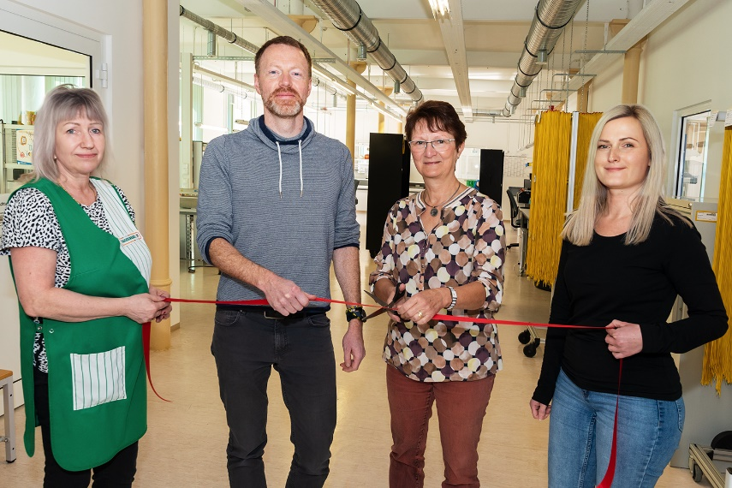
Image 1: Opening of the new production facility for specialty optical fibers. ©LWL-Sachsenkabel GmbH

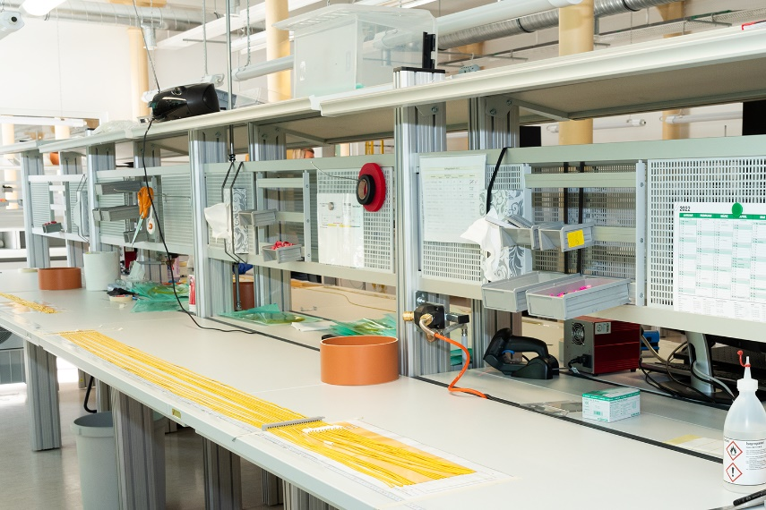
Image 2: New workplaces created for specialty optical fiber production. ©LWL-Sachsenkabel GmbH

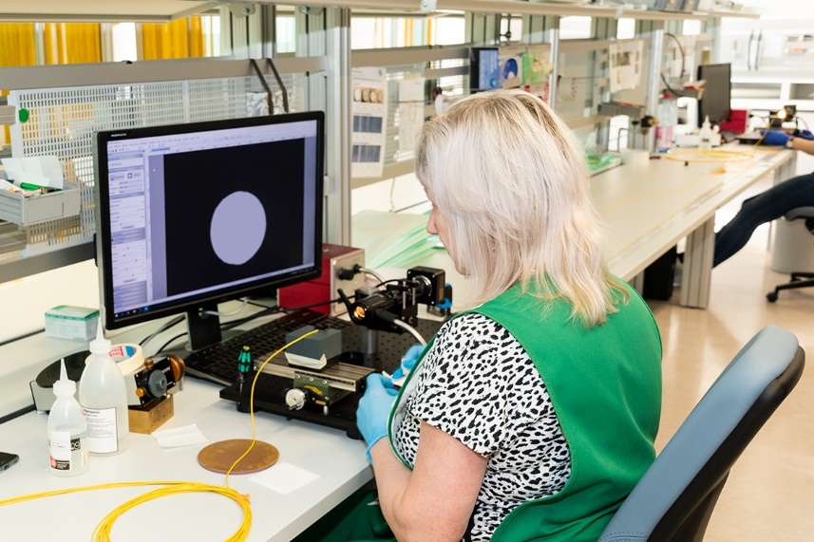
Image 3: Quality assurance through microscopic end face inspection. ©LWL-Sachsenkabel GmbH

About Sachsenkabel
LWL-Sachsenkabel GmbH located in Gornsdorf / Ore mountains, was founded in 1991. It is a subsidiary of Amphenol Corporation and one of the leading German manufacturers of fiber optic cabling systems. The focus of the business activities are fiber optic solutions for telecommunications, broadband development, data center, industry, and broadcast as well as specialty fibers for demanding laser and spectroscopic applications. Sachsenkabel stands for high-quality and technologically pioneering solutions and has developed into one of the largest specialists for fiber optic assembly in Germany. The high capacity of plug assemblies per day enables flexible and fast realization of customer-specific requirements. Firmly integrated into the economic region of Chemnitz, the company today has a team of more than 170 highly qualified employees and supplies customers at home and abroad.

Press contact LWL-Sachsenkabel GmbH:
LWL-Sachsenkabel GmbH
Hauptstraße 110
DE-09390 Gornsdorf/Erzgebirge
Phone: 03721 3988-0
Fax: 03721 3988-16
info@sachsenkabel.de
www.sachsenkabel.de

