Sachsenkabel to be Europe's first OFS Fitel, LLC. Partner
for the distribution of AccuCore HCF™ Hollow-Core Fiber

Patented air-core fiber reduces latency by around 30 percent

LWL-Sachsenkabel GmbH is the first European distributor of OFS Fitel, LLC. for the patented AccuCore HCF™ (Hollow-Core Fiber). The premium fiber was developed for high-speed data transmission and enables a reduction in latency of around 30 percent compared to glass fibers with silica-based solid core. This makes it particularly suitable for use in high-performance computers as well as for time-critical applications such as high-frequency trading on stock exchanges.

Gornsdorf/Ore Mountains, September 22, 2022 – LWL-Sachsenkabel GmbH is Europe's first sales partner for the patented AccuCore HCF™ hollow-core fiber from OFS Fitel, LLC.. The fiber was developed for high-speed data transport and enables higher transfer rates than conventional solid core fibers. Instead of a silica-based core, the HCF fiber (Hollow-Core Fiber) transmits the light signals via an air core. The latency time is thus reduced by around 30 percent, which corresponds to a time saving of 1.5 microseconds per kilometer of transmission distance. It is therefore particularly suitable for applications in which latency values are of greater importance than attenuation. It is used, among other things, in high-performance computers as well as in time-critical applications such as high-frequency trading on stock exchanges and in banking. In the near future, further areas of application with low latency tolerance are to be added, including autonomous driving, 5G antenna connection and secure communications.

Accucore currently supports data transmission in the wavelength-range centered at 1550nm – however, OFS is working on expanding the spectrum of wavelengths. It is available in indoor and outdoor versions. Users can choose between cable types with two or four fibers; link lengths from one meter up to one kilometer are available. Since the fibers can be equipped with standard connectors such as LC and SC, they can be easily integrated into standard solid-core fiber networks.

Currently, Sachsenkabel still obtains the pre-assembled cables directly from OFS. In the future, however, individual fitting at the Saxon production site will also be implemented. The fiber optic supplier is happy to advise you in project planning, as well as with questions about the product and its possible areas of application. More information can also be found at: https://bit.ly/accucore-hcf

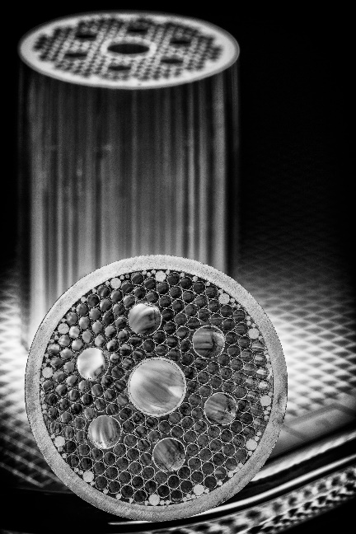

Picture 1: The AccuCore HCF™ takes advantage of the fact that light travels faster in air than in glass. (© OFS Fitel, LLC.)

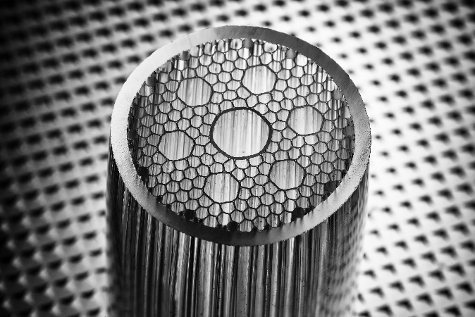

Picture 2: Patented AccuCore HCF™ hollow-core fiber with air core instead of silica-based core (© OFS Fitel, LLC.).

Über Sachsenkabel
Die 1991 gegründete LWL-Sachsenkabel GmbH mit Sitz in Gornsdorf/Erzgebirge ist ein Unternehmen der Amphenol Corporation und zählt zu den führenden deutschen Herstellern von LWL-Verkabelungssystemen. Schwerpunkte der Geschäftstätigkeit sind Glasfaserlösungen für Telekommunikation, Breitbandausbau, Rechenzentrum, Industrie und Broadcast sowie Spezialfasern für anspruchsvolle lasertechnische und spektroskopische Anwendungen. Sachsenkabel steht für qualitativ hochwertige und technologisch zukunftsweisende Lösungen und hat sich unter anderem zu einem der größten Spezialisten für Glasfaserkonfektionierung in Deutschland entwickelt. Die hohe Kapazität an Steckerkonfektionen pro Tag ermöglicht dabei eine flexible und schnelle Realisierung kundenspezifischer Stückzahlen. Fest eingebunden in die Wirtschaftsregion Chemnitz, beschäftigt das Unternehmen heute mehr als 170 hochqualifizierte Mitarbeiter und beliefert Kunden im In- und Ausland.

Pressekontakt LWL-Sachsenkabel GmbH:
LWL-Sachsenkabel GmbH
Hauptstraße 110
09390 Gornsdorf/Erzgebirge
Telefon: 03721 3988-0
Telefax: 03721 3988-16
info@sachsenkabel.de
www.sachsenkabel.de

