Press Release

formnext 2022: Laserline shows diode-laser-based solutions for cladding and additive manufacturing

Focus topics are processing differing materials with blue lasers and
brake disc coatings that reduce fine dust pollution

Highlights of Laserline’s presence at formnext 2022 include cross-material cladding and additive manufacturing processes through application of blue lasers, and infrared-laser-based hard coatings for wear reduction in brake discs. Those interested can find us at Hall 12, Booth B19.

Mülheim-Kärlich, November 2, 2022 – At formnext (November 15-18 in Frankfurt am Main, Germany) Laserline will present diode-laser-based solutions for cladding and additive manufacturing and will focus on two primary topics. One is the application of blue lasers for coating processes and additive manufacturing of metal components, enabling exceptional results both for highly reflective non-ferrous and numerous other metal types. The other illustrates an infrared-laser-based, high-speed process for hard material coatings on brake discs, and contributing to fine dust reduction for both road vehicles and rail traffic. Interested parties can find out more in Hall 12, Booth B19.

Representing the next milestone in Laserline’s blue system development, the world’s first 3 kW cw blue laser ‘LDF_{blue} 3000-30’ will be presented in Frankfurt as an innovative solution for coating and additive manufacturing processes. Although originally developed for processing of copper (due to the metal’s vastly better absorption at these wavelengths), blue laser systems have since proved their real effectiveness in other areas of metal processing. Iron, cobalt and nickel, for example, all exhibit quiet melt pools and can be processed with high efficiency. In the coating sector, extremely resistant metallurgical bonds are created between the coating and base material. And for additive manufacturing, highly stable and precisely machined components can be realized. The improvement in optical output to 3 kW (with 30 mm·mrad beam quality and ~445 nm wavelength) further expands the spectrum of potential applications and additionally opens up new opportunities for processing pure copper (as opposed to copper alloys only, as previously). Visitors will also be able to view a much more compact LDM_{blue} system providing up to 2 kW output and which, for particularly straightforward integration, is available as a 19‘‘ rack-mount module occupying 5 or 7 vertical rack units.

Laserline’s second, and in general highly topical focus at formnext is the powder-based high-speed process with infrared diode lasers for applying very hard coatings to brake discs. By the application of very thin but nonetheless extremely wear and corrosion-resistant coatings to brake discs for road (cars, buses, trucks) and rail network traffic, tangible reductions in fine dust (particulate) pollution can be targeted.

As usual, Laserline will make all of these solutions accessible at the formnext booth via video and animated presentations. Multiple examples of each described metal processing type are also presented.

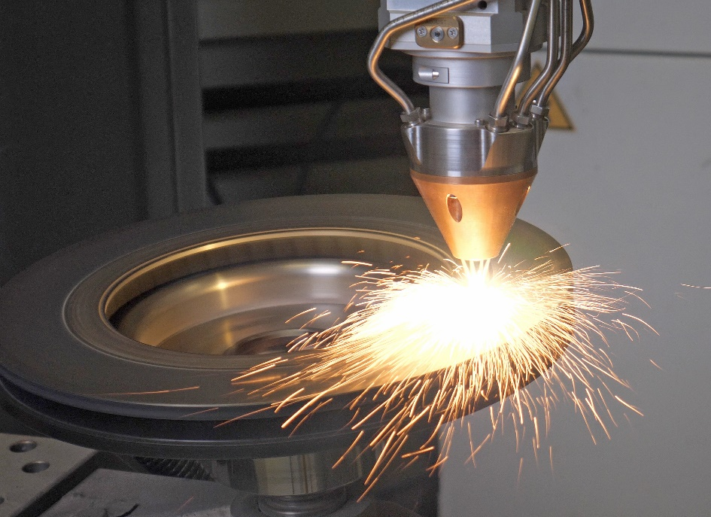
Figure 1: Powder-based laser coating of a brake disc. ©Laserline

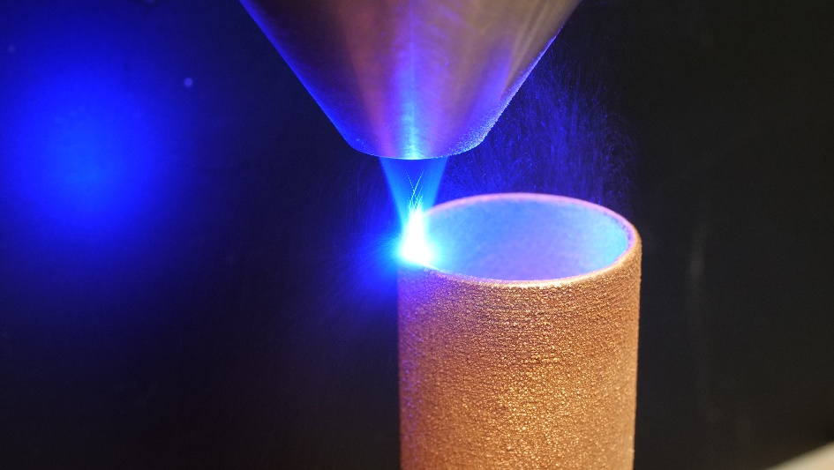
Figure 2: Additive manufacturing of copper components with a blue diode laser. ©Laserline

About Laserline:
Laserline GmbH, based in Mülheim-Kärlich, close to Koblenz, Germany, was founded in 1997. As a leading international manufacturer of diode laser systems for industrial material processing, the company has established itself as a cornerstone of this innovative technology and can look back on more than 25 years of company history. Roughly 6,000 Laserline high-power diode lasers have been installed worldwide, demonstrating their performance in a wide variety of processes and applications. Laserline currently employs around 350 people and has international subsidiaries in the USA, Mexico, Brazil, Japan, China, South Korea and India, as well as representatives in Europe (France, Great Britain, Italy) and in the Asia-Pacific region (Australia, Taiwan, Singapore). Sustainable growth is at the core of the company’s strategy, and with the construction of an extensive building complex located in Mülheim-Kärlich, the requirements for the future expansion of both development and production are already assured. Further information is available at https://www.laserline.com/en-int/

Contact company:  Laserline GmbH  Stefan Aust  Fraunhofer Strasse  56218 Mülheim-Kärlich, Germany  Tel. +49 (0)2630 964-1440  Fax +49 (0)2630 964-1018  Stefan.Aust@laserline.com  www.laserline.com | Contact agent:  Riba:BusinessTalk GmbH  Michael Beyrau  Klostergut Besselich  56182 Urbar/Koblenz, Germany  Tel. +49 (0)261-963 757-27  Fax +49 (0)261-963 757-11  mbeyrau@riba.eu  www.riba.eu

