Management change at LWL-Sachsenkabel GmbH

Dr. Michael Müller new General Manager since 1 January 2023

Dr. Michael Müller (38) is the new General Manager of LWL-Sachsenkabel GmbH from 1st January 2023. Michael Müller who holds a PhD in mechanical engineering, succeeds Silvia Duus, who will retire after 15 years leading the company. He aims to continue the growth strategy of the established fiber optic cabling specialist and, above all, take advantage of the business opportunities in the field of broadband development.

Gornsdorf/Ore Mountains, 2nd January 2023 – at the turn of the year LWL-Sachsenkabel GmbH also turned the page to a new management. Dr . Michael Müller (38) is the General Manager of the fiber optic cabling specialist from Gornsdorf, Saxony, since 1 January 2023. He succeeds Silvia Duus, who will retire after 15 successful years at the helm of the company.

Silvia Duus joined LWL-Sachsenkabel GmbH in 2001 as Technical Director. After making important contributions to product and production development as well as acquiring new customers, the physicist was appointed to the management board in 2007. Her work at the top of the company combines the continuous rise of Sachsenkabel from a pure fiber optic assembly company to one of the leading German solution providers for fiber optic-based infrastructures in the telecommunications, data center, broadcast, sensor technology, industrial production and medical technology sectors.

Her successor, Dr. Michael Müller, intends to continue this consistent growth strategy. The doctor of mechanical engineering previously worked in various leading positions as well as in the management of an international specialist in electron and laser beam technology and has many years of experience in sales, project and product management as well as comprehensive expertise in the field of production technology. For Michael Müller, product innovation and production optimization are the central pillars of the future development of LWL-Sachsenkabel GmbH, especially with regard to solutions for the business segment of broadband development.

Silvia Duus has accompanied LWL-Sachsenkabel GmbH for more than two-thirds of its company history and made a decisive contribution to the successful establishment of the company in a highly competitive market segment. Sachsenkabel would like to thank Silvia Duus for her many years of commitment to the company and its employees and wishes her many wonderful years in her well-deserved retirement.

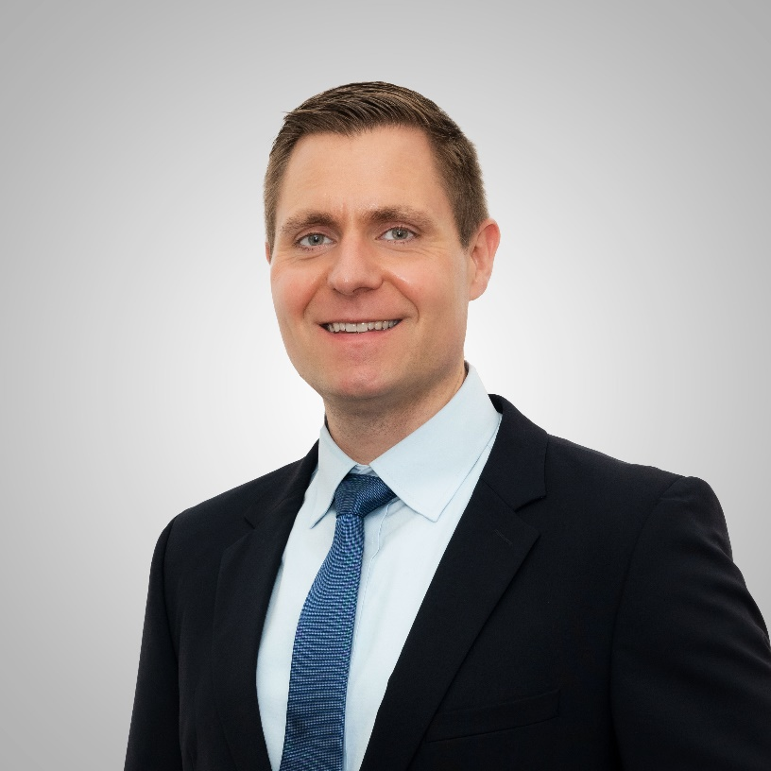
Image 1: Dr. Michael Müller (38) is the new General Manager of LWL-Sachsenkabel GmbH from 1st January 2023. © LWL-Sachsenkabel GmbH

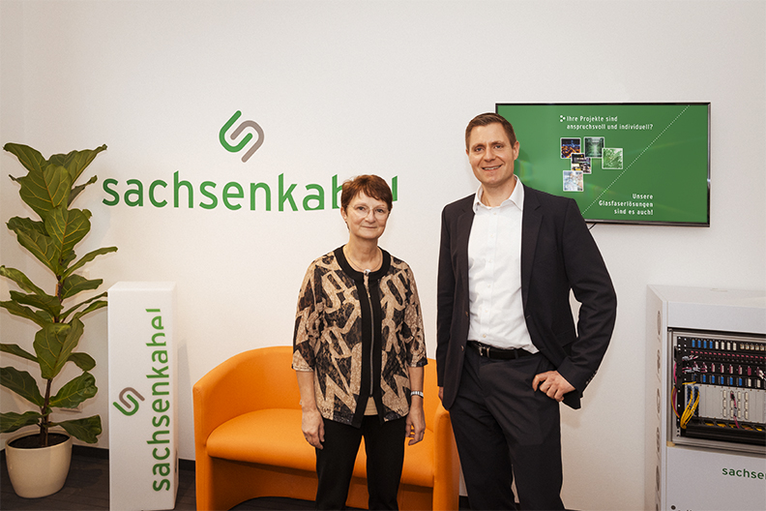
Image 2: Dr. Michael Müller (right) succeeds Silvia Duus (left), who will retire after 15 successful years at the helm of the company. © LWL-Sachsenkabel GmbH

About Sachsenkabel
LWL-Sachsenkabel GmbH, located in Gornsdorf / Erzgebirge mountains, was founded in 1991. It is a subsidiary of Amphenol Corporation and one of the leading German manufacturers of fiber optic cabling systems. Business activities focus on fiber optic solutions for telecommunications, broadband development, data center, industry and broadcast as well as specialty fibers for demanding laser and spectroscopic applications. Sachsenkabel stands for high-quality and technologically pioneering solutions and has developed into one of the largest specialists for fiber optic assembly in Germany. The high capacity of connector assemblies per day enables flexible and fast realization of customer-specific quantities. Firmly integrated into the economic region of Chemnitz, the company today employs more than 170 highly qualified employees and supplies customers at home and abroad.

Press contact LWL-Sachsenkabel GmbH:
LWL-Sachsenkabel GmbH
Hauptstrasse 110
09390 Gornsdorf/Erzgebirge
Germany
Phone: 03721 3988-0
Fax: 03721 3988-16
info@sachsenkabel.de
www.sachsenkabel.de

