**Press Release**

**Battery Show 2023:**

**Laserline to exhibit energy-efficient applications for e-mobility**

**Economic series manufacturing of batteries, e-motors and brake disc claddings**

*At the Battery Show 2023 Laserline will present energy-efficient solutions for industrial material processing in the field of electromobility. Key topics include copper welding with blue 3 kW cw diode lasers, brake disc cladding to reduce urban particulate pollution, laser drying processes for economical series manufacturing of lithium-ion batteries, and welding applications for sealing battery casings.*

**Mülheim-Kärlich, April 6, 2023 –** Diode laser specialist Laserline will be presenting its portfolio of solutions for economic series manufacturing of batteries, electric motors and brake disc coatings at Battery Show 2023 (May 23-25 in Stuttgart, Hall 8, Booth E81). Among the highlights of the trade show presentation is the world's first blue diode laser with 3 kW cw output power, which has been developed in particular for the processing of copper components – for example as used in electrical drive technology or for power electronics. This industrial laser represents the highest currently available power class in the blue wavelength spectrum around 445 nm, a wavelength which is more effectively absorbed by non-ferrous metals than infrared radiation. Among other aspects, blue lasers enable near-surface heat conduction welding of thin copper components and offer two decisive advantages over competing approaches that utilize green laser light: Firstly, direct light generation using laser diodes eliminates the need for complex and efficiency-reducing frequency conversion. Secondly, the laser systems exhibit a significantly smaller footprint, which enables straightforward system integration. And up to cw output powers of 2 kW, the blue lasers are even available in a compact 19" rack format, making integration still easier.

Another focus of the trade show exhibit is a laser drying process for low-emission and cost-effective series manufacturing of lithium-ion batteries. It was developed as part of the IDEEL research project (Implementation of Laser Drying Processes for Economical & Ecological Lithium-Ion Battery Production) – under the leadership of Laserline – and enables the production of laser-dried anodes and cathodes in a roll-to-roll process for the first time. In this process, the diode laser supplements or replaces the market-dominating convective drying process and reduces the total energy requirement for drying by more than 25 percent, while at the same time enabling a reduction in necessary production area. When considering circuit loads of over 1,000 kW for a conventional GigaFab drying line, this makes significant CO2 savings achievable and thus represents an energy turnaround for this type of production process.

Laserline is also presenting a high-speed, series mature process suitable for cost-effective hard coating of brake discs. This process enables the realization of very thin yet wear-resistant claddings that combine long-term corrosion and abrasion protection. These types of cladding reduce the amount of the environmentally and health-hazardous PM10 particulate matter (up to 10 µm) generated through braking by up to 90 percent. This also ensures compliance with the requirements of the upcoming Euro 7 vehicle emission standard, which is due to come into force in 2025 and for the first time sets specific limits for particulate emissions from braking systems.

As a further highlight, Laserline will be showing diode laser-based welding solutions for sealing battery casings. Both hot wire and spot-in-spot module optic applications will be presented here, the latter describing a narrowly focused internal spot that is overlaid by a larger rectangular spot. Compared to conventional processes such as MSG or MIG welding, both approaches promise higher process speeds, improved gap bridging ability and durable welds of excellent quality.

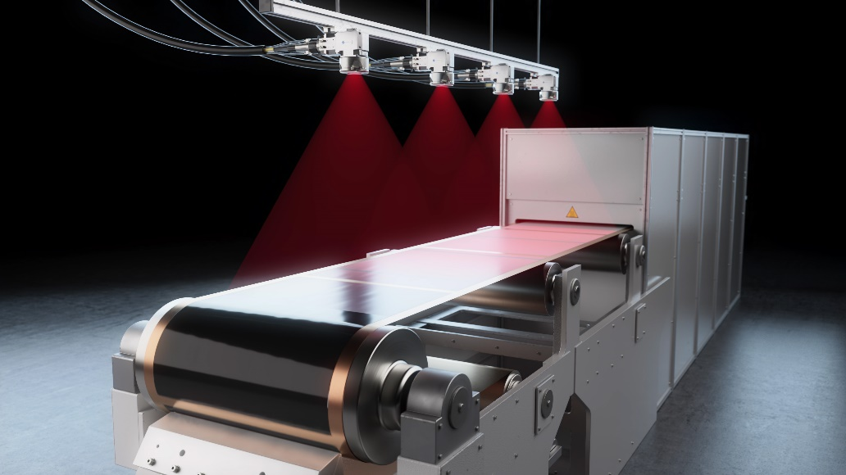

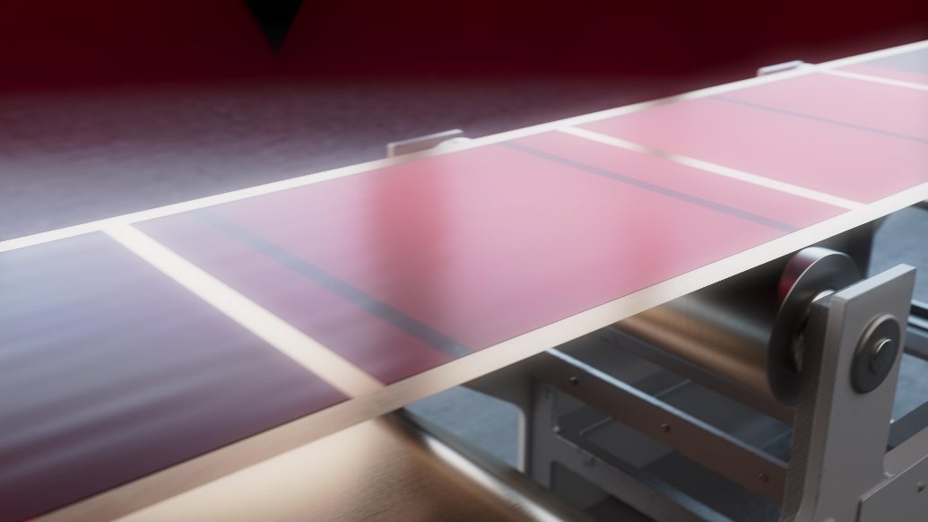

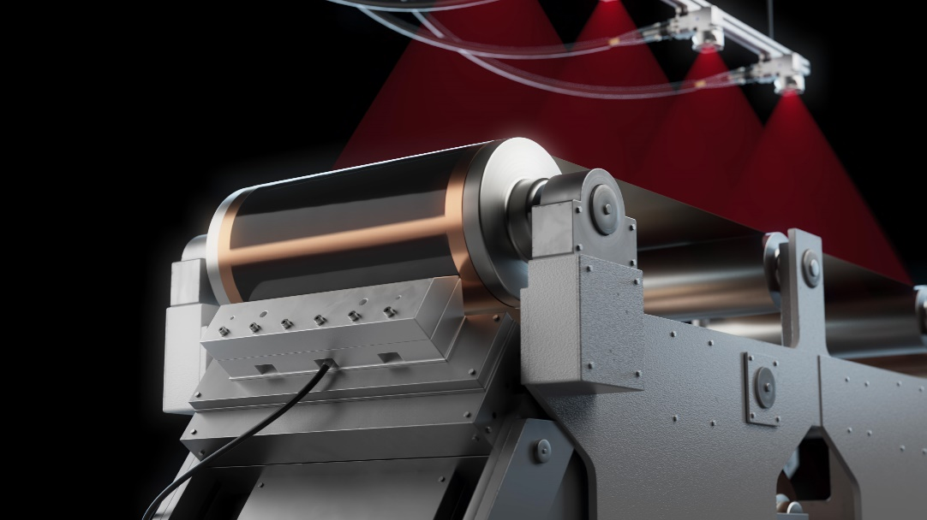

**Fig. 1-3: Production of laser-dried anodes and cathodes in a roll-to-roll process. ©Laserline**

**About Laserline:**

Laserline GmbH, based in Mülheim-Kärlich, close to Koblenz, Germany, was founded in 1997. As a leading international manufacturer of diode laser systems for industrial material processing, the company has established itself as a cornerstone of this innovative technology and can look back on more than 25 years of company history. Roughly 6,000 Laserline high-power diode lasers have been installed worldwide, demonstrating their performance in a wide variety of processes and applications. Laserline currently employs around 350 people and has international subsidiaries in the USA, Mexico, Brazil, Japan, China, South Korea and India, as well as representatives in Europe (France, Great Britain, Italy) and in the Asia-Pacific region (Australia, Taiwan, Singapore). Sustainable growth is at the core of the company’s strategy, and with the construction of an extensive building complex located in Mülheim-Kärlich, the requirements for the future expansion of both development and production are already assured. Further information is available at <https://www.laserline.com/en-int/>

|  |  |
| --- | --- |
| **Contact company:**  **Laserline GmbH**  Stefan Aust  Fraunhofer Strasse  56218 Mülheim-Kärlich, Germany  Tel. +49 (0)2630 964-1440  Fax +49 (0)2630 964-1018  [Stefan.Aust@laserline.com](mailto:Stefan.Aust@laserline.com)  [www.laserline.com](http://www.laserline.com) | **Contact agent:**  **Riba:BusinessTalk GmbH**  Michael Beyrau  Klostergut Besselich  56182 Urbar/Koblenz, Germany  Tel. +49 (0)261-963 757-27  Fax +49 (0)261-963 757-11  [mbeyrau@riba.eu](mailto:mbeyrau@riba.eu)  [www.riba.eu](http://www.riba.eu) |