July 2024

More safety and efficiency when lifting loads

**RUD BUDDYtron app: the digital guide to lifting**

* **Assistance with choice, assembly, visual inspection and repair of lifting means and lifting points**
* **Product information and instructions can be retrieved directly on site**
* **More safety and efficiency in lifting**

Aalen, July 2024– **Digital advice on lifting loads – that’s what the new BUDDYtron app from RUD has to offer. The tool assists you with the choice, assembly, visual inspection and repair of lifting means and lifting points and helps to make lifting processes safer and more efficient. The key component of the app is an extensive database, which, in addition to detailed information on all RUD products, also bundles numerous assembly and test instructions as well as valuable practical tips in the form of texts, images and videos.**

With BUDDYtron, the German provider of lifting and lashing means is pursuing the goal of making the daily planning and performance of lifting operations easier by providing fast and targeted information and preventing incorrect use scenarios involving lifting means. A central function of the app is product identification via NFC, which allows users to access product information directly on site. Almost all RUD products are therefore equipped as standard with a highly robust RFID transponder, with which the products can be easily identified via smartphone. The app then automatically calls up all stored product information, such as technical data and operating instructions – so that users have every desired document at hand within a few seconds.

**Lifting points and lifting means check**

When selecting components, the integrated lifting point check provides important assistance: in just a few steps, it is possible to check whether a lifting point is suitable for lifting a certain load. To do this, the user first identifies the lifting point via NFC or selects it via a product search or article number. In addition, it stores central parameters for the intended lifting operation, such as the weight of the load, with just a few clicks. The app then starts the automatic check and delivers a clear result after just a few seconds. The app’s lifting means check also works in this way, allowing the selected lifting means configuration to be checked for its suitability for the respective application, taking the useful length and number of strands, among others, as a basis. The BUDDYtron app also offers support when performing visual inspections, for example before the use of a lifting chain: users can send photos to RUD at any time to obtain a technical assessment of the component status – quickly and easily from the app. In case of more specific enquiries or remaining uncertainties, users can also contact RUD specialists directly via the app and obtain individual advice.

**Free download**

“With BUDDYtron, we are providing users with a tool that offers them professional support quickly and easily during a variety of lifting operation – and all of that at any time and conveniently with a smartphone. There is currently no comparable solution on the market that offers users a similar amount of added value,” says Fabian Bihlmaier, Product Manager for Sling and Lashing Systems at RUD. “And that’s not all: because the BUDDYtron range of functions will be expanded even further in the future.” The app will be available for free download for iOS and Android in the respective stores in the German and English language versions (more language versions to follow) from the beginning of July and is compatible with NFC-enabled devices.

Further information on the functions and release of the app is also available at [www.buddytron.app](https://slingandlashing.rud.com/en/buddytron).

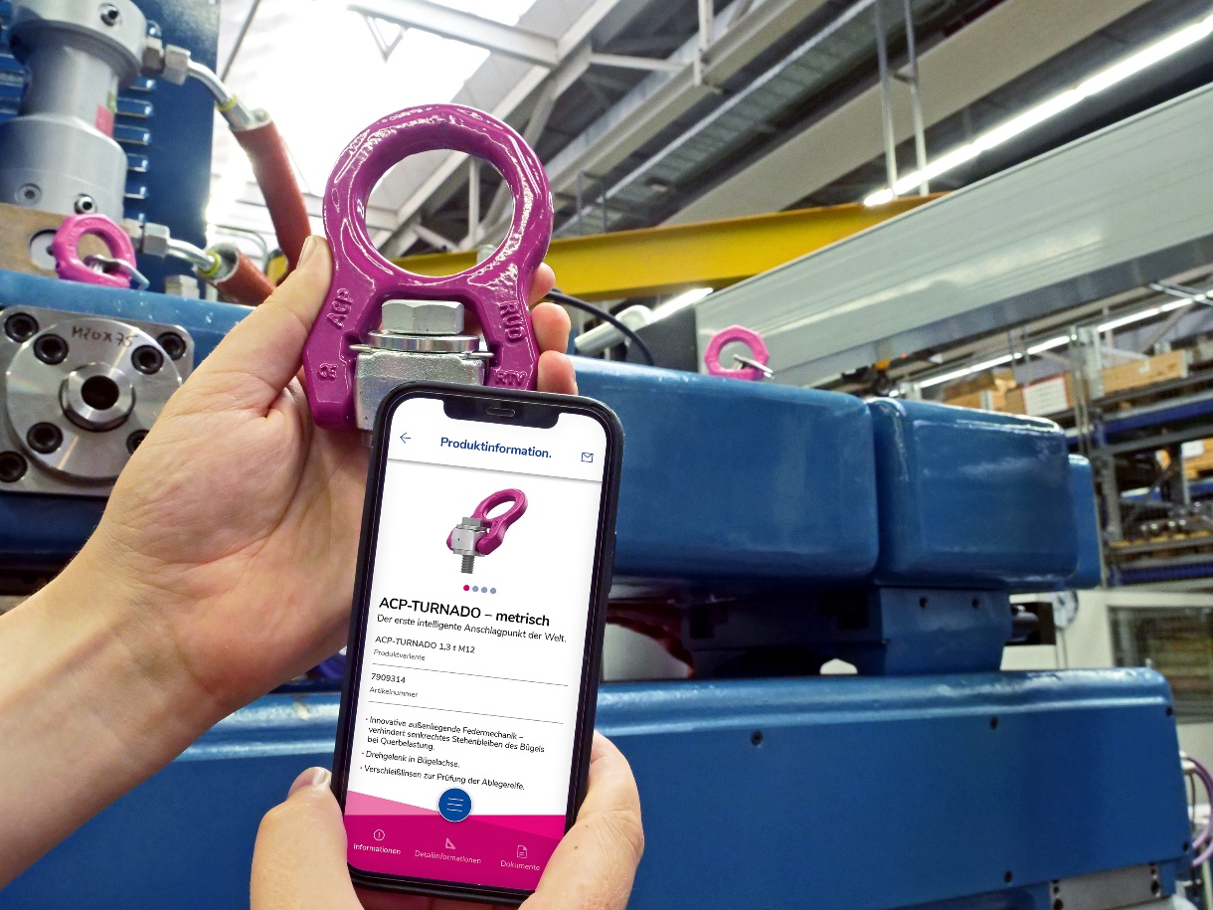

***Image: Product data can be directly read out on site by NFC thanks to RUD’s Buddytron app. ©RUD***

**The company**

RUD Ketten Rieger & Dietz GmbH u. Co. KG, founded in 1875 by Carl Rieger and Friedrich Dietz in the Swabian city of Aalen, achieves with over 1700 employees in more than 120 countries an annual turnover of over 250 million euros. At locations, among others in Germany, Australia, Brazil, China, India, Romania and the USA, the family business, alongside lifting technology, also manufactures lashing technology and anti-skid chains, as well as hoisting chains and conveyor systems. With the Erlau brand, the Aalen-based company also manufactures tyre protection chains and property furnishings for indoor and outdoor areas.

**Your contact:**

RUD Ketten Rieger & Dietz GmbH u. Co. KG

Lea Thiele – Marketing Manager

Friedensinsel

73432 Aalen, Germany

Phone: +49 7361 504-1463

www.rud.com

lea.thiele@rud.com