August 2025

Subject:Extended portfolio of DNV-certified lifting means for a wide variety of application scenarios

**SPE Offshore Europe 2025: RUD presents onshore, offshore and subsea lifting technology**

Aalen, August 2025 – **At SPE Offshore Europe (2 to 5 September, Aberdeen, Scotland), RUD is going to focus on marine, offshore and subsea lifting technology solutions. Among other things, the company will present its broad portfolio of DNV-certified products for use in shallow water and the deep sea as well as on board ships, in ports and on offshore platforms. All the presented components have been developed for use under extreme conditions and meet the highest quality and safety requirements – even in changing and extreme weather conditions.**

The highlight of RUD’s stand at the exhibition will be the ACP-TURNADO lifting point, which is now also available in an offshore version with a zinc flake coating. The ACP-TURNADO was developed in 2019, specifically for rotating and turning loads. Its intelligent spring mechanism effectively prevents the lift bail from stopping in the worst case position under a transverse load and then suddenly twisting out of this position. Instead, the lift bail automatically aligns itself to the pulling direction, thus consistently preventing shock loads. The new boltable ACP-TURNADO for offshore use was tested for corrosion resistance in a salt spray test lasting 720 hours in accordance with DIN EN ISO 9227. The lifting point is also certified in accordance with DNV-ST-0377 and DNV-ST-0378 and is therefore – just like weldable lifting points – perfect for maritime and offshore applications. The DNV-certified version of the ACP-TURNADO is available in the sizes M8 to M30. All the components have a maximum hardness of 380 HV.

Other highlights of RUD’s exhibition stand will include the ROV-Hook, a hook that was designed specifically for lifting heavy loads under water. In the optimised version, the ROV-Hook now has a zinc flake coating on the twin-trigger mechanism and the hook latch, which increases the corrosion resistance and further improves the product’s durability. The hook can be operated by all common ROV manipulators (ROV = remotely operated vehicle, a remote-controlled underwater robot) and makes it possible to carry out a large number of lifting and transport tasks, for example when assembling subsea structures in the deep sea. The ROV-Hook offers a number of advantages in comparison with conventional hooks: the hook is equipped with an outwards-opening safety latch, which can only be opened when the twin trigger is activated. When the underwater robot releases the trigger, the latch closes automatically and reliably remains locked, thus preventing the load from being released unintentionally. In contrast to other models available on the market, the latch can be opened and closed with just one ROV grabber, which also makes the hook easier to handle. In addition, the design deliberately dispensed with a protruding hook nose to minimise the risk of it unintentionally getting caught in something. Two versions of the ROV-Hook (10t and 25 t) will be exhibited at the exhibition stand.

Another exhibition highlight is the model of a DNV-certified (DNV-ST-0377 and DNV-ST-0378) 4-leg sling with appropriate VLBG 10.9 lifting points. It is suitable for a wide variety of offshore and heavy-load applications. The VLBG series is available with WLLs of 0.3 t to 4 t and with a captive, but exchangeable 10.9 bolt. Its eccentric design allows an automatic alignment in the direction of the force, increasing the safety during lifting operations. The standard clamping spring achieves noise reduction and keeps the suspension ring in the desired direction, thereby making it easier to hinge the lifting means and ensuring a flat design in the folded state.

The lifting technology specialist will also provide information about its entire range of DNV products. These include, for example, the INOX-ABA weldable stainless steel lifting point, which is often used to secure lifeboats or large consumer electronics systems and can also be used as a fall arrest anchor point in the 1.6 tonne version. Weldable W-ABA lifting points, VLBS load rings and various components for VIP chain slings such as the VVGS clevis shackle and the VIP multi-shortening claws will also be presented. Their areas of application range from port logistics and lifting on deck to pipeline construction and a wide variety of applications in the wind energy sector. A selection of the solutions will be exhibited at the exhibition stand.

The company

RUD Ketten Rieger & Dietz GmbH u. Co. KG, founded in 1875 by Carl Rieger and Friedrich Dietz in the Swabian city of Aalen, achieves an annual turnover of over 250 million euros with more than 1700 employees in more than 120 countries. At locations in Germany, Australia, Brazil, China, India, Romania and the USA, among others, the family business manufactures lifting technology and lashing technology, anti-skid chains, hoist chains and conveyor systems. With the Erlau brand, the Aalen-based company also manufactures tyre protection chains and interior and exterior fixtures and fittings.

Your contact:

RUD Ketten Rieger & Dietz GmbH u. Co. KG

Lea Thiele – Marketing Manager

Friedensinsel

73432 Aalen, Germany

Phone: +49 7361 504-1463

[lea.thiele@rud.com](mailto:lea.thiele@rud.com)

[www.rud.com](http://www.rud.com)

[www.slinglashing.rud.com](http://www.slinglashing.rud.com)

Photos:

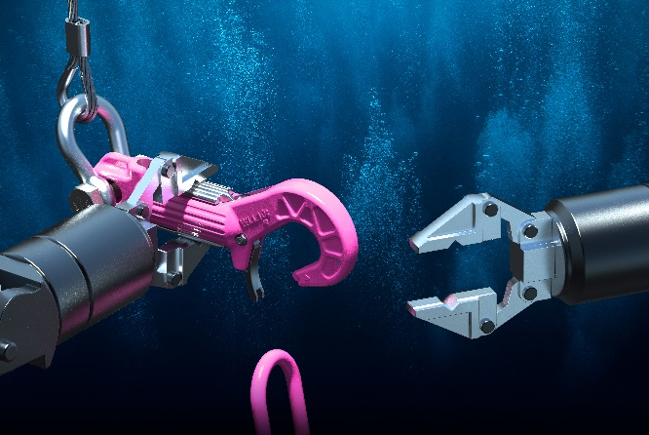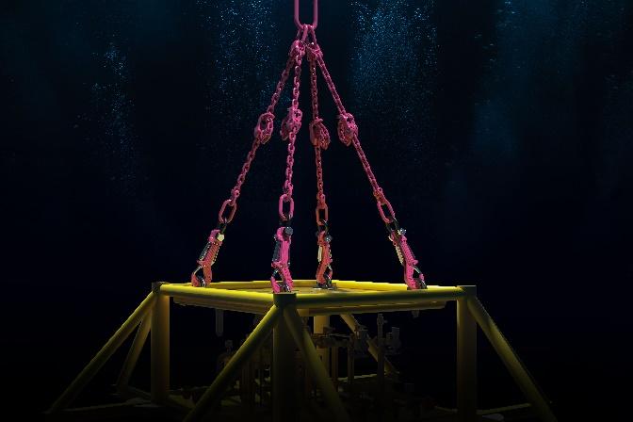

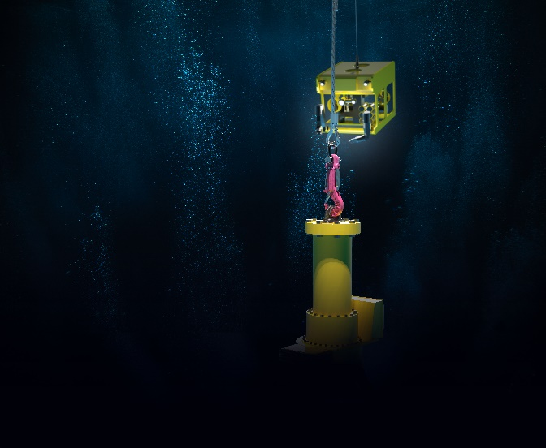

***Image 1 – 3: The ROV-Hook was developed specifically for lifting heavy loads under water. In the updated version, the hook now has a zinc flake coating on the trigger mechanism and the hook latch, which increases the corrosion resistance and further improves the product’s durability. ©RUD***

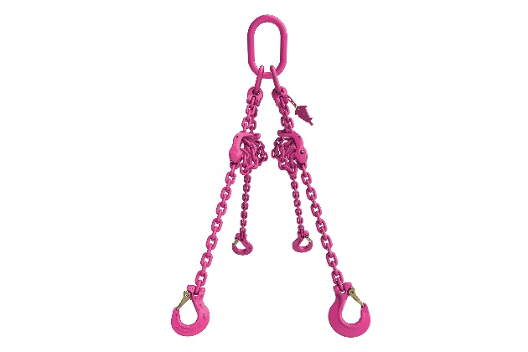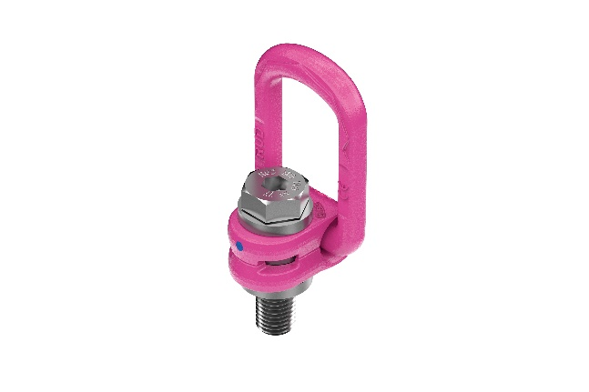

***Image 4 and 5: Another exhibition highlight is the model of a DNV-certified 4-leg sling with appropriate VLBG 10.9 lifting points, which is suitable for a wide variety of offshore and heavy-load applications. ©RUD***