From manufacturing to maintenance: integrated system solutions from a single source

Lifting and Moving in Railway Technology: RUD and RUD+SpanSet Plauen at InnoTrans 2026

Tried-and-tested lifting and load-handling solutions for the railway industry – ranging from standardised components to fully customised load-handling devices – this is the focus of RUD and RUD+SpanSet Plauen at InnoTrans 2026 (22 to 25 September 2026, Hall 6.2b, Stand 420).

Aalen, August 2026 – RUD and the joint venture RUD+SpanSet Plauen will be presenting a wide range of solutions for the safe and efficient lifting, moving and lashing of loads at InnoTrans in Berlin (22 to 25 September 2026, Hall 6.2b, Stand 420). The joint trade fair presence focuses in particular on applications in the production and maintenance of rail vehicles, with an emphasis on combining standard components and customer-specific solutions to create fully integrated lifting concepts. For example, a detailed model is used to demonstrate how to replace an ICE air-conditioning unit. The exhibition also features tried-and-tested standard products such as clickable clevis shackles, hoist rings, weldable chain connections, rotatable lifting points and lifting chains.

Engineering expertise throughout the entire life cycle

The tools shown are based on lifting concepts that have proven their worth in real-life practice and can be adapted to suit different requirements and locations. At the stand, RUD, together with RUD+SpanSet Plauen, will also be providing information on its comprehensive range of services covering the entire life cycle of rail vehicles – from initial design through to commissioning and testing, right through to maintenance.

Equipment for railway stations and transport facilities

In addition, Erlau, also part of the RUD Group, is showcasing durable and vandal-resistant solutions for railway stations and transport facilities in Hall 7.1b, Stand 360, including seating for platforms and waiting areas.

Free trade fair tickets: Free visitor tickets are available for RUD’s customers and prospective clients via the following link:
https://www.rud.com/en/company/latest-news/trade-fairs-and-events/innotrans-2026-registration

The company

RUD Ketten Rieger & Dietz GmbH u. Co. KG was founded in 1875 by Carl Rieger and Friedrich Dietz in the Swabian city of Aalen and achieves an annual turnover of more than €250 million with over 1700 employees in more than 120 countries. The family business manufactures lifting and lashing technology, non-skid chains, hoist chains and conveyor systems at locations including Germany, Australia, Brazil, China, India, Romania and the USA. With the Erlau brand, the Aalen-based company also manufactures tyre protection chains and interior and exterior fixtures and fittings.

Your contact:
RUD Ketten Rieger & Dietz GmbH u. Co. KG
Lea Gentner – Marketing Manager
Friedensinsel
73432 Aalen, Germany
Phone: +49 7361 504-1463
lea.gentner@rud.com
www.rud.com

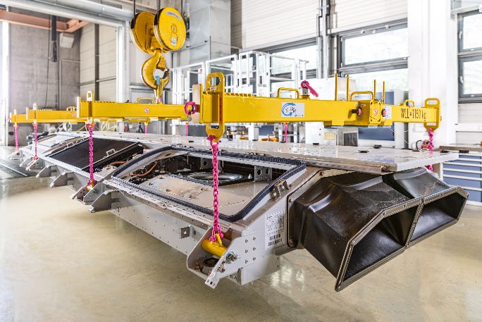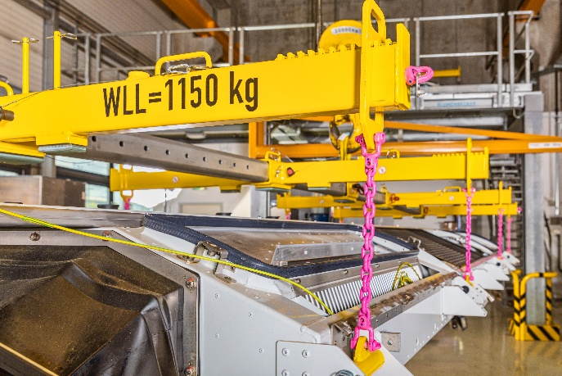
Image 1 and 2:
Caption: RUD and RUD+SpanSet Plauen are presenting a wide range of solutions for the production and maintenance of rail vehicles at InnoTrans.
Image source: RUD+SpanSet Plauen

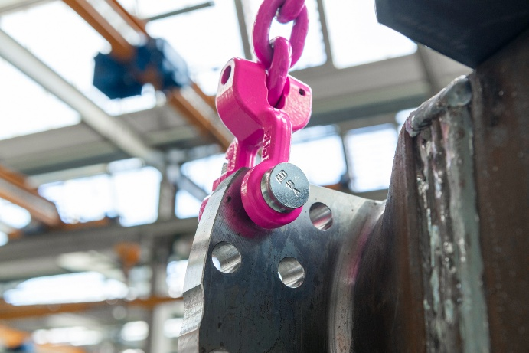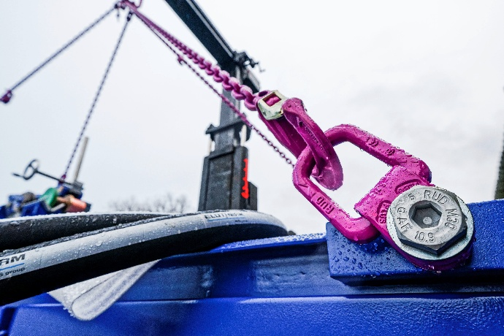
Image 3 and 4:
Caption: Tried-and-tested standard products such as the CCS-FASTLOX click-in fork-head shackle and the VLBG-PLUS lifting point, which can be adjusted in the direction of force, will also be on display at the stand.
Image source: RUD

