First lifting point with DNV certification for subsea operations

Brand new star in maritime lifting technology: the ACP-TURNADO OCEANSTAR by RUD

RUD is expanding its range of tried-and-tested ACP-TURNADO lifting points to include one designed for maritime environments. The ACP-TURNADO OCEANSTAR is the first lifting point to be certified by DNV for subsea applications. It is therefore ideal for use in offshore structures, such as wind farms and drilling platforms, as well as in shipyards, subsea construction projects and the associated supply industry.

Aalen, 1 September 2026 – In underwater lifting operations, lifting points are typically employed as connecting elements between the lifting means and the load. However, until now, there have been no lifting points on the market that have been specifically designed for underwater applications and hold the relevant certifications. This gap is now being filled by the ACP-TURNADO OCEANSTAR; the new member of the ACP-TURNADO family by RUD. Designed specifically for underwater operations, it is the first lifting point ever to be certified in accordance with DNV ST-0377 and ST-0378 for subsea operations. This means that an officially approved lifting point is now available for the first time for lifting operations in offshore wind farms, shipyards and a wide variety of underwater construction projects. Compared with conventional lifting points, it offers a range of technological advantages.

Protection against shock loads thanks to special spring mechanism

The RUD ACP-TURNADO OCEANSTAR is clearly superior to conventional lifting points of a similar shape and design, simply because its WLL is up to 30 per cent higher. This WLL reserve offers a crucial safety advantage, particularly during dynamic load peaks, which occur regularly in the splash zone. Furthermore, like all ACP-TURNADO lifting points from RUD, the ACP-TURNADO OCEANSTAR is fitted with a special spring mechanism that stops the lift bail from staying vertical and prevents it from flipping over. The lift bail always aligns automatically in the direction of force instead. This prevents shock loads caused by the load dropping suddenly following a change in the lift bail's position. Such shock loads endanger not only the load itself, but also the crane, the load handling equipment, and any people involved.

Exceptionally high resistance to corrosion and degradation

Another factor that contributes to safety is the exceptionally high corrosion and material degradation resistance of the ACP-TURNADO OCEANSTAR. All lifting point components have a zinc flake coating, which guarantees salt spray resistance of at least 720 hours in accordance with DIN EN ISO 9227. The maximum hardness of ≤38 HRC in all components provides long-term protection against hydrogen embrittlement. Furthermore, the 10.9 bolt used in the ACP-TURNADO OCEANSTAR boasts at least 36 joules at -40°C in a notch bar impact test, providing high resistance to hydrogen
embrittlement. The technical parameters comply with all the relevant requirements of NORSOK R-002, DIN EN 1677-1, US standard ASME B30.26:2015, and DGUV-R 109-017:2020-12. The striking golden colour of the lift bail ensures good visibility underwater, making handling easier and improving safety during diving and maintenance operations. The RUD ACP-TURNADO OCEANSTAR comes in thread sizes M8 to M30 and with a WLL of 0.5 to 8 tonnes. It is available to order straight away and ready for delivery from October.

Gallery:

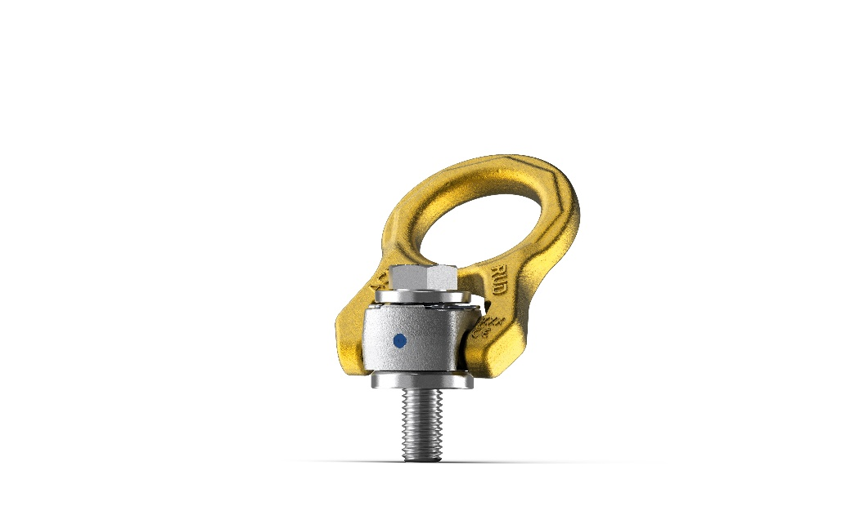
Image 1: Designed specifically for underwater operations, the RUD ACP-TURNADO OCEANSTAR is the first lifting point ever to be certified in accordance with DNV ST-0377 and ST-0378 for subsea operations. Image source: RUD

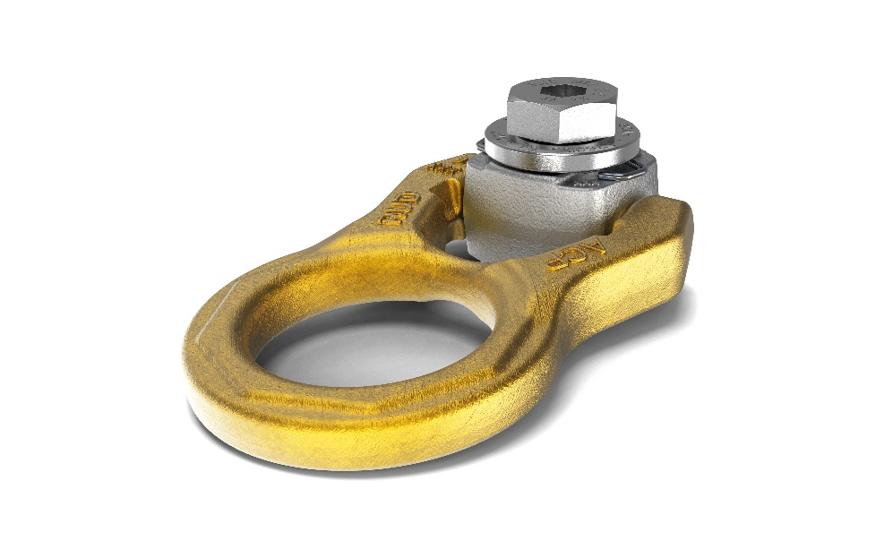
Image 2: The ACP-TURNADO OCEANSTAR from RUD has a spring mechanism to keep the lift bail vertical and delay flipping, thereby preventing shock loads. The lift bail always aligns in the direction of force instead. The striking golden colour of the lift bail ensures good visibility underwater, making handling easier and improving safety during diving and maintenance operations. Image source: RUD

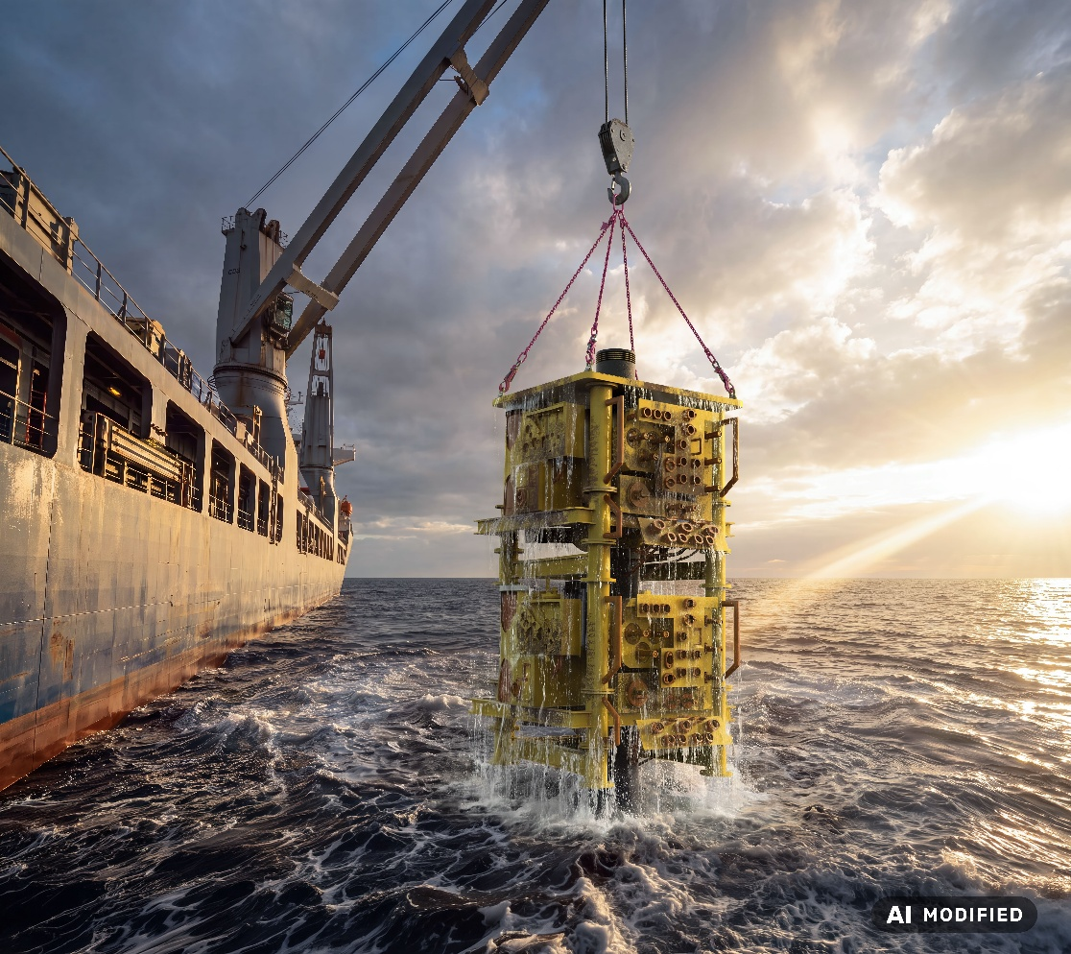
Image 3: A crucial safety advantage is offered by the increased WLL of the ACP-TURNADO OCEANSTAR, including during dynamic load peaks in the splash zone. Image source: RUD
The company

RUD Ketten Rieger & Dietz GmbH u. Co. KG was founded in 1875 by Carl Rieger and Friedrich Dietz in the Swabian city of Aalen and achieves an annual turnover of more than €250 million with over 1700 employees in more than 120 countries. The family business manufactures lifting and lashing technology, non-skid chains, hoist chains and conveyor systems at locations including Germany, Australia, Brazil, China, India, Romania and the USA. With the Erlau brand, the Aalen-based company also manufactures tyre protection chains and interior and exterior fixtures and fittings.

Your contact:
RUD Ketten Rieger & Dietz GmbH u. Co. KG
Lea Gentner – Marketing Manager
Friedensinsel
73432 Aalen, Germany
Phone: +49 7361 504-1463
lea.gentner@rud.com
www.rud.com
www.slinglashing.rud.com

