Press Release

Laserline at Formnext 2026: Diode Laser Systems for Additive Manufacturing and Cladding

Focus on Copper-Based Powder Bed Fusion, Economical Internal Diameter Cladding, and Intelligent Process Control

From the additive manufacturing of copper components to the economical functionalization of internal surfaces and complex geometries: At Formnext 2026, Laserline (Hall 12, Booth C122) will present diode laser-based solutions for efficient and reliable manufacturing. The trade show highlight will be a new laser system for the additive manufacturing of copper components using blue lasers in the Laser Powder Bed Fusion (LPBF) process.

Mülheim-Kärlich, 21 October 2026 – Diode laser specialist Laserline will present innovative solutions for additive manufacturing and laser cladding at Formnext 2026 (November 17–20, Frankfurt am Main, Germany). The highlight of this year’s trade show appearance is a new, high-brightness laser system for copper processing in powder bed applications using a blue diode laser. The system enables the highly efficient additive manufacturing of components made of gold, copper, and other reflective metals in a laser powder bed fusion process thanks to its excellent absorption in non-ferrous metals. The new system also features an output power of 750 watts and a scanner unit for achieving particularly small spot sizes. At the booth (Hall 12, Booth C122), visitors can see complex, high-resolution cooling structures that demonstrate the capabilities of high-brilliance blue lasers in the production of delicate, pore-free components.

Efficient, Wire-Based Coating Processes
In the area of laser cladding, Laserline will present solutions for wire-based cladding using single-wire technology. Depending on the material, either IR or blue lasers are used. Combined with customized beam shaping, these systems enable controlled and stable processes, reproducible coating properties, and efficient material utilization. At the booth, Laserline will display coated plain bearing pads with white metal coatings applied to steel and copper substrates. These examples demonstrate the potential of laser cladding for demanding applications, such as in axial plain bearings.

New High-Power Solution for Internal Coatings
Another trade show highlight is Laserline’s OTI solution developed for high-performance internal coating of components such as pipes, pump cylinders, and extruder parts. The new optics design enables the coating of complex component geometries and hard-to-reach surfaces, such as those found on truck brake discs. Thanks to its compact design and angled nozzle shape, the OTI optics enable reliable and efficient coating even in areas that are difficult to reach with conventional optics.

Large penetration depths of up to several meters support precise laser beam guidance along the pipe axis and ensure homogeneous coatings over the entire component length while maintaining high reproducibility. Combined with high-power diode lasers, high material deposition rates and process speeds are possible, even on larger internal surfaces. In addition, its space-saving design makes the optics well suited for integration into automated manufacturing processes. A truck brake disc sample will be on display at the booth.

Process Monitoring for Reproducible Results
Also on display will be a cladding optic featuring integrated sensors for process monitoring and control. The presented closed-loop solution collects process data in real time and uses this information to automatically adjust the laser power. This ensures consistent coating quality even under changing process conditions. The solution helps reduce scrap and rework while supporting efficient quality assurance and greater process reliability.

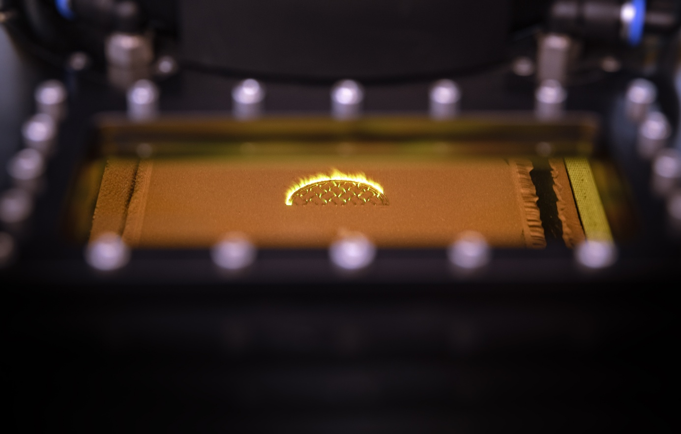
Image 1: Laserline's new blue high-brilliance laser system opens up new possibilities for the additive manufacturing of filigree and high-density copper components using the powder bed fusion process. Source: Laserline

About Laserline:

Laserline GmbH, based in Mülheim-Kärlich near Koblenz, was founded in 1997. The company is a world leader in the development and manufacture of extremely efficient, modular diode laser systems at blue and infrared wavelengths. Laserline high-power diode lasers achieve output powers of up to 60 kW and an electrical efficiency (WPE) of over 56%. Based on decades of experience, Laserline develops customized laser solutions for industrial applications – including high-quality beam-shaping optics for the realization of variable spot geometries – and has established itself internationally as a reliable partner. More than 8,500 high-power diode lasers from Laserline are currently in use around the world, demonstrating their performance in a wide variety of processes and applications. The laser technology specialist currently employs around 440 people and has international subsidiaries in the USA, Mexico, Brazil, Japan, China, South Korea and India. Further information at https://www.laserline.com/en-int/

Contact Company:  Laserline GmbH  Stefan Aust  Fraunhofer Straße  D-56218 Mülheim-Kärlich  Tel. +49 (0) 2630 964-1440  Fax +49 (0) 2630 964-1018  Stefan.Aust@laserline.com  www.laserline.com | Contact Agency:  riba:businesstalk  Michael Beyrau  Klostergut Besselich  D-56182 Urbar/Koblenz  Tel. +49 (0)261-963 757-27  Fax +49 (0)261-963 757-11  mbeyrau@riba.eu  www.riba.eu

