April 2026

Ready when it matters

RUD Defence with defence technology solutions at the Eurosatory 2026.

RUD Defence will be showcasing lifting means and system solutions for lifting, securing and moving defence equipment under the slogan “Ready when it matters” at the EUROSATORY in Paris from 15 to 19 June 2026. The exhibition stand focuses on bespoke solutions that have already proven their worth worldwide in the most demanding operating conditions.

As a long-standing member of the Federal Association of the German Security and Defence Industry (BDSV), RUD will be exhibiting in the association’s shared exhibition area in Hall 6, Stand J329, within the German Pavilion. With an exhibition space twice the size of its previous one, the global market leader is emphasising its role as a strategic partner to the industry. With over 150 years of experience, a high degree of vertical integration under the “Made in Germany” label and approval as a NATO and German Bundeswehr supplier, RUD is a well-established systems supplier to international armed forces and global OEMs. At the world’s leading trade fair for defence and security, RUD will present solutions that cover the entire logistics chain for the sector. A key focus is bespoke systems that are tailored precisely to specific applications.

Selected exhibition highlights

Customised lifting harnesses: We design bespoke systems for complex tasks such as lifting tank turrets and ammunition racks.
Load securing and recovery: Designed to withstand even the most extreme conditions down to –60 °C, these robust lashing and recovery systems are ideal for heavy haulage and the recovery of combat vehicles.
Anti-skid chains: Mobility solutions include the ROTOGRIP rotary track, which provides instant traction at the touch of a button, and the robust PENTA, which is specially designed to provide heavy military vehicles with maximum traction in the most adverse conditions.
Heavy-lifting solutions (OX+RUD): High-performance lifting beams and hoists for the heaviest loads, which round off RUD’s portfolio as a full-service provider.

Forward-thinking solutions to meet the highest requirements

RUD is currently investing in the development of new solutions for the defence industry. At the EUROSATORY, the company will offer an early look at new lifting and lashing points that comply with STANAG and MIL international standards. By doing this, RUD is emphasising its ambition to play a leading role in setting future standards for lifting, securing loads and recovering military equipment.

Certified quality and high-end service

RUD solutions can be identified worldwide by their NATO Stock Number (NSN), and they meet the highest international standards, including MIL-SPEC, STANAG, ASME, and DIN. The variability in surface technology is also one-of-a-kind. In addition to a variety of colours and the classic powder coating, RUD uses a high-quality zinc flake coating to maximise durability in harsh environments and guarantee superior corrosion resistance.

In addition to supplying equipment, RUD offers comprehensive lifecycle services, including the development of bespoke loading concepts and the professional repair and crack testing of used systems. These systems are restored to near-new condition following a general overhaul at RUD.

Key data and arranging an appointment

Location: Parc des Expositions Paris-Nord Villepinte, Hall 6, Stand J329 (German Pavilion).
Registration: Visitors who are interested can register with RUD for the trade fair in advance via the links below, and arrange an appointment:

DE: https://www.rud.com/unternehmen/aktuelles/fachmessen-und-events/eurosatory-2026-anmeldung
EN: https://www.rud.com/en/company/latest-news/trade-fairs-and-events/eurosatory-2026-registration

The company

RUD Ketten Rieger & Dietz GmbH u. Co. KG, founded in 1875 by Carl Rieger and Friedrich Dietz in the Swabian city of Aalen, achieves an annual turnover of over 250 million euros with more than 1700 employees in more than 120 countries. At locations in Germany, Australia, Brazil, China, India, Romania and the USA, among others, the family business manufactures lifting and lashing technology, anti-skid chains, hoist chains and conveyor systems. With the Erlau brand, the Aalen-based company also manufactures tyre protection chains and interior and exterior fixtures and fittings.

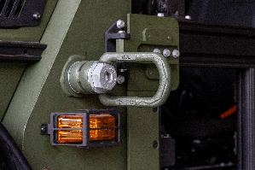
Image: RUD_Defence_PM_Eurosatory_01
Image caption: These specially coated RUD lifting points meet the highest military standards, offering optimum performance in extreme operating conditions
Image source: RUD / ACS

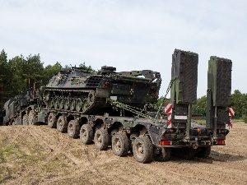
Image: RUD_Defence_PM_Eurosatory_02
Image caption: RUD certified lashing systems provide reliable load securing for military vehicles on rail, road and sea
Image source: RUD / DOLL

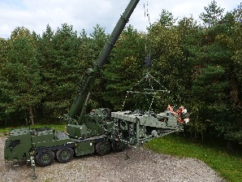
Image: RUD_Defence_PM_Eurosatory_03
Image caption: RUD lifting systems and lifting beams allow military equipment to be recovered, loaded or relocated quickly and safely in the field
Image source: RUD

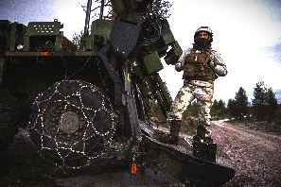
Image: RUD_Defence_PM_Eurosatory_04
Image caption: RUD's innovative anti-skid chains are specially designed for military wheeled vehicles, offering unparalleled off-road performance and traction on snow and ice
Image source: RUD

Your contact:
RUD Ketten Rieger & Dietz GmbH u. Co. KG
Lea Thiele – Marketing Manager
Friedensinsel
73432 Aalen, Germany
Phone: +49 7361 504-1463
lea.thiele@rud.com
www.rud.com

