“We share the load”: Lifting solutions for offshore and subsea applications

RUD at SMM 2026: Development expertise and DNV-certified lifting equipment for safe operations in the maritime environment

From planning and operation to service – RUD provides support to maritime lifting applications, even in the most challenging environmental conditions. The company will showcase its application and development expertise at SMM 2026 in Hamburg and will present DNV-certified lifting equipment and innovative specialised solutions, including those developed through collaborative partnerships.

Aalen, July 2026 – Whether onshore, offshore, or subsea: safety, corrosion resistance and reliability are crucial for lifting solutions in the maritime environment. RUD will use the opportunity at SMM in Hamburg (1-4 September, Hall A1, Stand 321) to demonstrate how these requirements can be fulfilled through collaborative partnerships, development expertise and DNV-certified lifting equipment under the motto “We share the load”.

As a highlight, RUD presents the new ACP-TURNADO OCEANSTAR, the first lifting point approved by DNV for subsea environments. Its spring mechanism ensures that the lift bail automatically aligns with the direction of the pull. It also has a highly durable zinc flake coating for optimised corrosion protection. Moreover, the show features a wide range of solutions for a diverse array of maritime applications, from multi-directional load-bearing lifting points and swivel eye bolts that can rotate 360° to various hoist rings. With Grade 10 VIP chains, the trade fair portfolio also includes DNV-certified lifting equipment. The products exhibited also meet NORSOK requirements, are all manufactured in Germany, and have been subject to comprehensive safety testing.

Among end components, RUD will be showcasing the ROV-HOOK. This is the result of a development partnership with Subsea7, a global provider of offshore solutions and services. Specially designed for offshore and subsea applications, the hook can be safely operated using standard ROV (Remotely Operated Vehicle) manipulators with its twin-trigger mechanism and automatic locking latches. The outwardly opening safety latch can only be opened by operating two release triggers. When the underwater robot releases the trigger, the latch closes automatically and remains securely locked, thus preventing the load from being released unintentionally. The optimised design also reduces the risk of the unintentional snagging of components. A ROV-HOOK will be displayed on the stand to enable visitors to see how it works. The company will also provide information regarding potential partnerships.

RUD will also be presenting products from OX+RUD Lifting Solutions. These include DNV-certified spreader beams for lifting beams in port environments, such as container handling. The company therefore offers a broad portfolio of coordinated components for use between the crane hook and the load.

Digital services complement the range of solutions

Finally, RUD’s trade fair offer will include information on digital tools for the planning, selection, application, documentation and inspection of high-quality lifting equipment. These include a configurator for lifting points and lifting equipment and the RUD BUDDYtron app, which you can use to access product data and operating instructions at any time.

Those interested can use the following link to schedule a personal appointment and request a free trade show ticket: https://www.rud.com/en/company/latest-news/trade-fairs-and-events/smm-2026-registration

Photos:

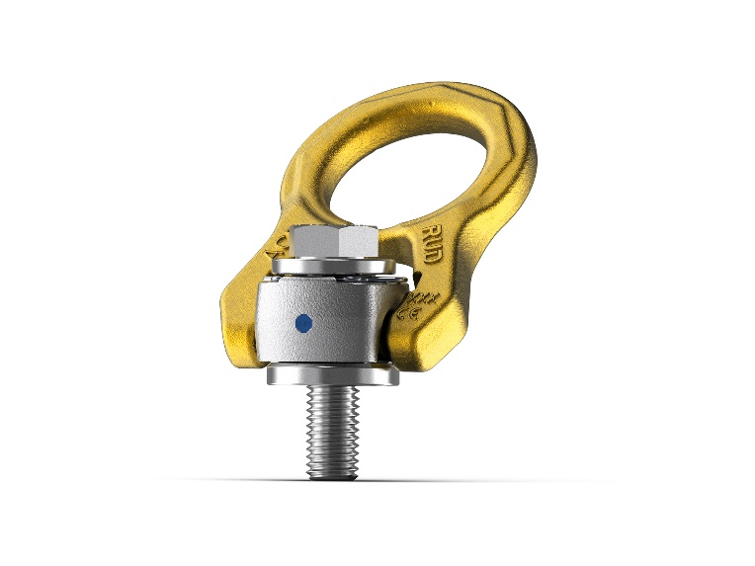
Image 1: The spring mechanism of the DNV-certified ACP-TURNADO OCEANSTAR automatically aligns the lift bail in the direction of the pull, while the highly durable zinc flake coating ensures reliable protection against corrosion. ©RUD

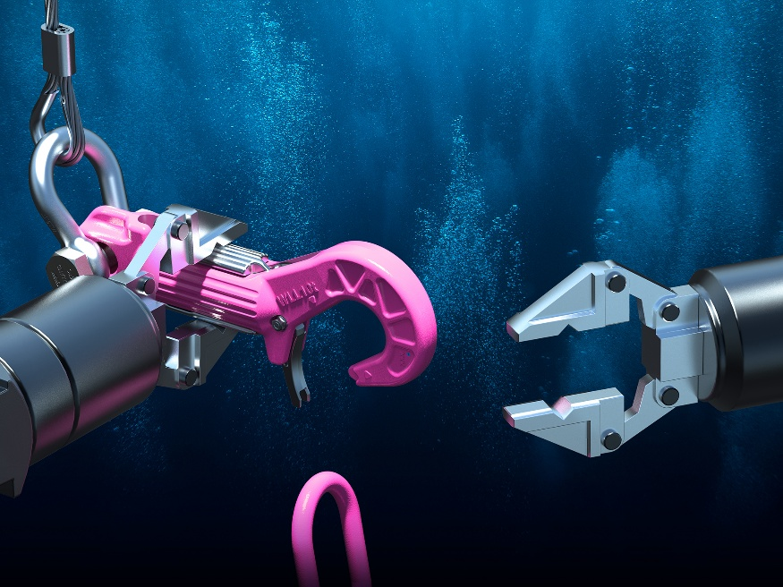
Image 2: The ROV-HOOK features a twin-trigger mechanism and an automatic locking latch system. The hook can therefore be operated safely using ROV manipulators, thus preventing accidental opening. ©RUD

The company

RUD Ketten Rieger & Dietz GmbH u. Co. KG was founded in 1875 by Carl Rieger and Friedrich Dietz in the Swabian city of Aalen and achieves an annual turnover of more than €250 million with over 1700 employees in more than 120 countries. The family business manufactures lifting and lashing technology, non-skid chains, hoist chains and conveyor systems at locations including Germany, Australia, Brazil, China, India, Romania and the USA. With the Erlau brand, the Aalen-based company also manufactures tyre protection chains and interior and exterior fixtures and fittings.

Your contact:
RUD Ketten Rieger & Dietz GmbH u. Co. KG
Lea Gentner – Marketing Manager
Friedensinsel
73432 Aalen, Germany
Phone: +49 7361 504-1463
lea.gentner@rud.com
www.rud.com
www.slinglashing.rud.com

