All process steps fully covered

Comprehensive solution providers for injection mold handling: RUD and RUD+SpanSet Ramstein at the Fakuma 2026

RUD and its joint venture, RUD+SpanSet Ramstein, will be showcasing their comprehensive solutions for the handling of injection molds at the Fakuma 2026, which takes place from 12–16 October in Friedrichshafen. The presented portfolio covers all process steps, including lifting and positioning, rotation and turning, opening and closing and also ensures safe, efficient and ergonomic handling. Visitors can find RUD and RUD+SpanSet Ramstein on stand B5-5109.

Aalen, 7 September 2026 – Whether it is the initial tooling phase, production, maintenance, logistics or decommissioning: Heavy injection molds often need to be lifted, positioned, rotated, turned, opened or closed quickly. This requires reliable, high-performance handling technologies that combine short set-up times with a high level of workplace safety and ergonomic process control.

More efficient, safer and more ergonomic handling process

The RUD Group and the RUD+SpanSet Ramstein joint venture, which serves as the group’s centre of excellence for tool and mold making, will be showcasing these technologies at the Fakuma 2026 (stand B5-5109). There, the two partner companies will present themselves as providers of comprehensive solutions for efficiently and safely handling tools that often weigh several tonnes. Not only are solutions presented for quick mold changes on the injection molding machine, but also for rotating, turning and separating the molds during cleaning, maintenance, transportation and storage. The company's exhibition stand will showcase bespoke solutions, including the custom manufacture of load handling equipment. In addition, the two partner companies will be showcasing their services in the areas of consultancy and solution configuration as well as the inspection service. In this context, visitors will also have the opportunity to discuss their handling challenges in toolmaking, injection molding or maintenance and repair services directly at the stand with industry-experienced experts from RUD and RUD+SpanSet Ramstein. Personal appointments can be arranged and free exhibition tickets requested at www.rud.com/en/fakuma-2026.

Lifting points with spring mechanism prevent shock loads

The RUD Group is showcasing the ACP-TURNADO lifting point, developed by its Sling & Lashing division, as a highlight of the trade fair in the field of lifting and positioning. It prevents the “shock loads” that many users fear, where heavy loads suddenly sag. This can cause damage to the loads themselves, the crane equipment and the load handling equipment. It can also pose a serious risk to those involved. Thanks to an integrated spring mechanism, the lift bail on the lifting point always aligns itself with the load direction, preventing it from remaining vertical and suddenly turning over. Dangerous transverse loads and a sudden drop of the load are therefore excluded. The RUD ACP-TURNADO has a WLL that is up to 30 per cent higher than standard lifting points of a similar shape and size, making it particularly suitable for handling heavy molds and tools.

Automatic hooks and central suspensions for fully automated lifting

The exhibition stand will feature a range of RUD solutions for lifting and positioning, including the versatile VWBG load rings. It will also showcase automatic hooks and ABZ central suspensions from RUD+SpanSet Ramstein. In practice, they are permanently attached to the crane system or the injection mold. When used together, they enable the rapid, safe and fully automated lifting of larger molds. This eliminates the need to attach the hook manually, meaning that operators do not have to climb onto the tool during this stage of the process and can maintain a safe distance.

Tools for safe and ergonomic turning and opening

For processes involving rotation, turning, opening and closing, RUD's Conveyor & Drives division presents its TECDOS TM series of turning tables and the TECDOS TSB mold openers. RUD turning tables can rotate injection molds weighing up to 64 tonnes by up to 90° around their centre of gravity in under a minute at the touch of a button, enabling them to be moved reliably and safely. RUD mold openers are suitable for injection molding tools weighing up to 2.5 tonnes, facilitating the controlled, manual opening of molds without the need for additional electrical, pneumatic or hydraulic power. Thanks to its ergonomic design, the platform also allows process steps such as cleaning, maintenance and repairs to be carried out directly on the work surface of both machines.

Exhibits demonstrate practical use

A series of exhibits – some models, some originals – demonstrate how injection molds are lifted, rotated, turned and transported using RUD and RUD+SpanSet Ramstein solutions. Further information on the handling solutions presented is also available online at slingandlashing.rud.com, moldhandling.rud.com and rudspanset.de/Ramstein.

Photos:

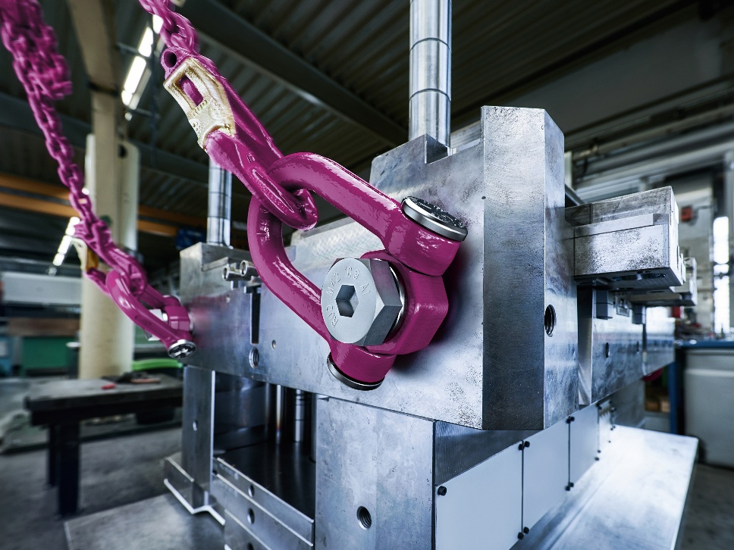
Image 1: The RUD ACP-TURNADO lifting point lift bail is shown here while lifting an injection mold. Thanks to an integrated spring mechanism, it automatically aligns itself in the load direction, thereby preventing dangerous transverse movements and sudden sagging of loads. Image source: RUD

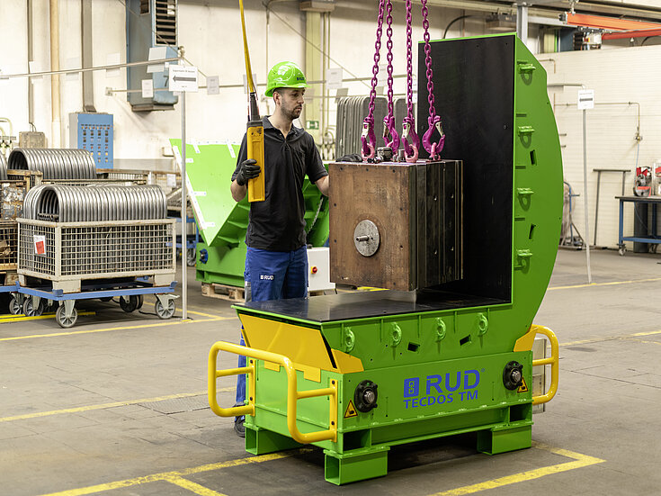
Image 2: A heavy injection mold is lifted onto a RUD turning table using RUD lifting technology. Image source: RUD

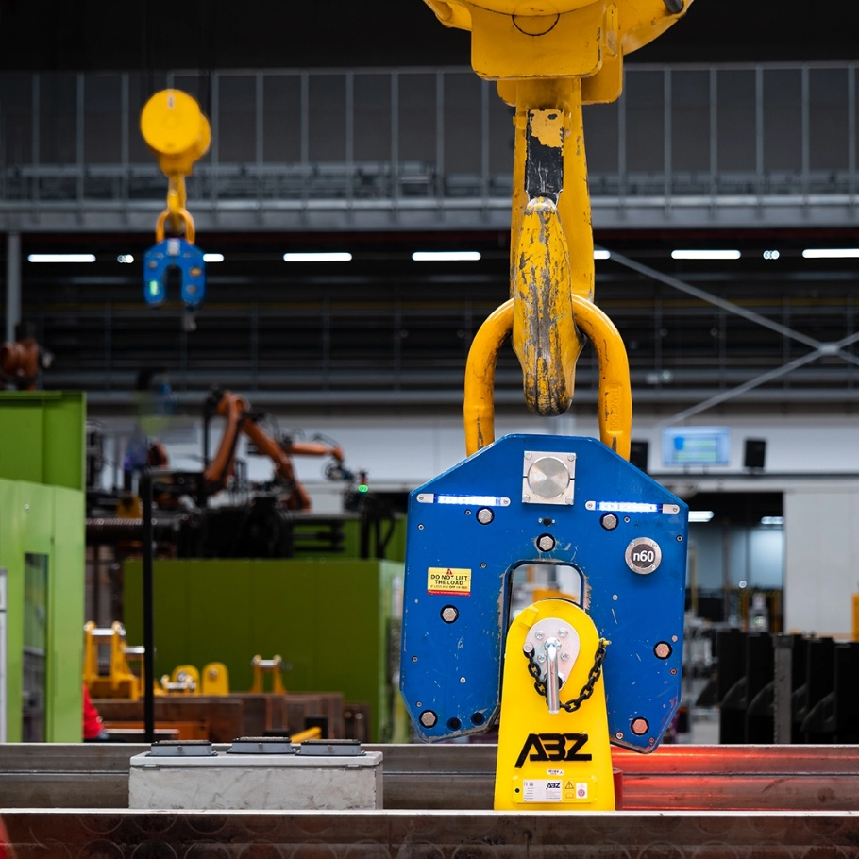
Image 3: When used in combination, the automatic hooks and ABZ central suspensions from RUD+SpanSet Ramstein enable the fully automated, rapid and safe lifting of larger molds. Image source: RUD

The company

RUD Ketten Rieger & Dietz GmbH u. Co. KG was founded in 1875 by Carl Rieger and Friedrich Dietz in the Swabian city of Aalen and achieves an annual turnover of more than €250 million with over 1700 employees in more than 120 countries. The family business manufactures lifting and lashing technology, non-skid chains, hoist chains and conveyor systems at locations including Germany, Australia, Brazil, China, India, Romania and the USA. With the Erlau brand, the Aalen-based company also manufactures tyre protection chains and interior and exterior fixtures and fittings.

Your contact:
RUD Ketten Rieger & Dietz GmbH u. Co. KG
Lea Gentner – Marketing Manager
Friedensinsel
73432 Aalen, Germany
Tel.: +49 7361 504-1463
lea.gentner@rud.com
www.rud.com
www.slinglashing.rud.com

