**IDEEL project: Industry-relevant scaling of laser drying processes for lithium-ion batteries is within reach**

**Innovative process technology enables energy-efficient drying of anodes and cathodes while at the same time reducing space requirements**

*As part of the IDEEL research project (Implementation of Laser Drying Processes for Economical & Ecological Lithium-Ion Battery Production), project partners from industry and research are developing a laser drying process for the more climate-friendly and economical serial production of lithium-ion batteries. Now, for the first time, the process has been successfully scaled up to a coating and drying speed of 5 m/min in a continuous process, proving that industrial implementation is technically possible and economically viable.*

**Mülheim-Kärlich, 09.04.2024 –** As part of the IDEEL research project, Fraunhofer ILT has succeeded for the first time this year in scaling up the laser drying process in an R2R (roll-to-roll) system from Coatema GmbH to a web speed of 5 m/min and demonstrating 2-stage laser drying. This doubling of the web speed (compared to the previous year) was made possible using laser beam sources and drying optics specially developed for the requirements of laser drying by Laserline. High-precision thermal cameras from Optris in combination with a laser power control system specially developed for this process ensure homogeneous drying. In combination with the short response time of the laser beam sources applied, this control concept enables highly dynamic process control. Furthermore, the thermographic images also enable reliable detection of defects in the electrodes - such as variations in layer thickness or unwanted particles in the layers.

At the same time, the research and development team of the coating machinery company Coatema optimized the drying and coating process using CFD (computational fluid dynamics) simulation to further improve the resulting electrode quality. The focus here was on improving the design of slot die geometry for the electrode coating process. In addition, the prototype laser drying unit with optimized air flow was recently realized at Coatema in Dormagen. This year, the laser optics developed by Laserline will be integrated into the system and the further upscaling of the drying process (up to 30 m/min) will be tested in the R&D Center of Coatema using high-power diode lasers.

Furthermore, the project partner PEM, Chair of Production Engineering of E-Mobility Components at RWTH Aachen University, has succeeded in reducing the drying time for LFP cathodes and graphite anodes by over 60 percent - and thus significantly reducing the energy requirement and CO2 footprint as predicted. To further develop the process in terms of materials, the partners at MEET (Münster Electrochemical Energy Technology) Battery Research Center at the University of Münster are currently working on new types of silicon-containing anodes to increase the performance of the batteries. These new developments are being tested for compatibility with the laser drying process in close collaboration with researchers at PEM and the Fraunhofer Institute for Laser Technology ILT, and any necessary adjustments are being made as required. Additional surveys conducted by the Fraunhofer Research Institution for Battery Cell Production FFB among users from industry and research also continuously provide new data on the current requirements for drying processes. Thus, enabling application-oriented development work. This comprehensive consideration of the overall system consisting of machinery technology, process and material development not only allows the project participants to implement and demonstrate the process close to industry, but also makes it possible to drive forward the currently rapidly changing battery production sector in Germany.

|  |
| --- |
| **IDEEL Project:**  The research project "IDEEL" is funded as part of the BMBF program Batterie2020 by the Federal Ministry of Education and Research (BMBF) under the funding code 03XP0414A through the project management organisation Project Management Jülich (Forschungszentrum Jülich GmbH).  The project partners are Laserline GmbH, Coatema Coating Machinery GmbH and Optris GmbH, as well as the Fraunhofer Institute for Laser Technology (ILT), the Fraunhofer Research Institution for Battery Cell Production (FFB), the Münster Electrochemical Energy Technology (MEET) Battery Research Center at the University of Münster and the Production Engineering of E-Mobility Components (PEM) at RWTH Aachen University. The aim of the three-year project is to develop an industry-relevant laser drying process that will enable series production of lithium-ion batteries that is both more climate-friendly and economical.  Initially, a new electrode paste optimized for laser use will be developed as a coating material (PEM, MEET), a highly efficient laser system with a large-area, homogeneous spot (Laserline) and a highly integrative thermographic camera for contactless process monitoring (Optris, Laserline, Fraunhofer ILT). Based on these contributions, the laser-based drying process will be scaled up to industry-typical feed rates within a demonstrator (Coatema) and the physics-based model of the new drying process subsequently validated (ILT, FFB).  The research results are to be incorporated into the FFB's processes in the future. The work of the FFB is considered one of the flagship projects of German battery research and is expected to become the principle development center of modern battery cell production for both Germany and European partners, with the goal of reducing German and European manufacturing dependence on the world market. A complete production infrastructure is therefore currently being built at the Münster site, with the intention of providing support to companies and research institutions seeking to test and optimize the series production of new battery designs. |

|  |
| --- |
| **Laser drying in the context of battery production:**The drying process addressed by the IDEEL project is part of the electrode manufacturing process for high-power battery cells, such as those used in electric vehicles and home storage systems. It is used to dry an electrode paste (slurry), which consists of a specially adjusted, homogeneous active material mixture and is applied to the copper foil of the battery electrode. Up to now, convection dryers have been used to dry this electrode coating, but the thermal energy transfer is only indirect into the material and thus places a heavy burden on both the CO2 balance and the energy costs of battery production. The IDEEL project partners are therefore focusing on up-scaling a more energy-efficient drying process in which the coating is irradiated using high-power diode lasers. The process benefits from the strong absorption of infrared laser light in the coating material, allows for more flexible and precise process control compared to common convection technology, and where the IDEEL project ultimately aims to demonstrate web speeds of up to 30 meters per minute. The compact design and efficient energy transfer are expected to significantly ease the extensive space requirements of the drying sections, which are typically more than 100 meters long – with a significantly reduced spatial footprint for the production environment, the planning of new production systems should enable faster and more energy-efficient process control. |

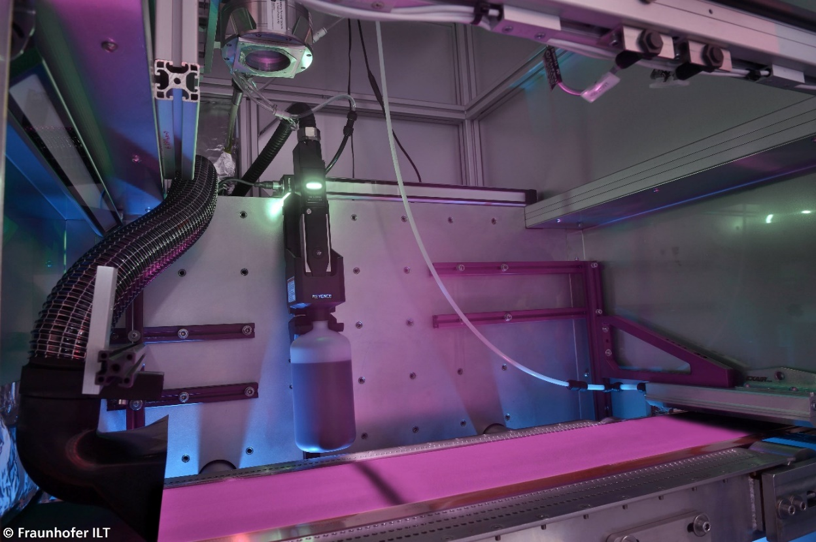

***Picture 1: 2-stage laser drying with a laser spot length of over 0.8m in the roll-to-roll battery drying system. (Source: Fraunhofer ILT)***

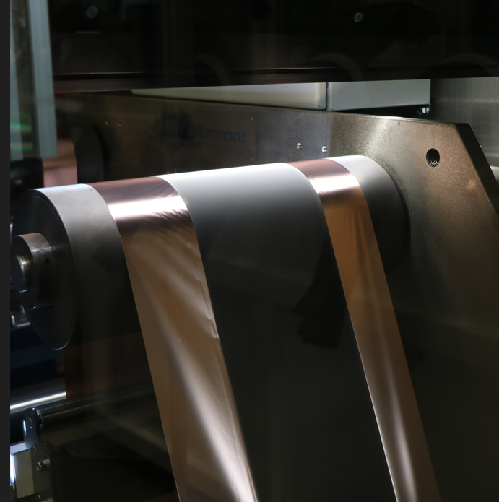

***Picture 2: Electrode foil after laser drying (Source: PEM | RWTH Aachen University)***