Press Release

Laserline Expands Corporate Headquarters in Mülheim-Kärlich, Germany

Diode Laser Specialist Strengthens Research and Applications

With the groundbreaking ceremony on June 16, 2026, marking the start of a comprehensive expansion of its headquarters in Mülheim-Kärlich near Koblenz, Laserline is sending a strong signal in support of Germany as a hub for innovation: Even amid a challenging economic environment, the internationally leading specialist in industrial diode lasers continues to grow steadily and carries its success story forward.

Mülheim-Kärlich, June 17, 2026 – The construction project includes a new, two-story production hall with approximately 3,250 square meters of floor space and a separate, two-story office building that offers around 1,300 square meters for modern workspaces. The new construction is linked to a strategic optimization of the existing plant structures: The application laboratories, where customer-specific processes and material compositions are tested, can be consolidated in a single location thanks to the additional capacities. This will free up valuable space in the existing buildings, which will be reserved for fundamental technological research and development.

Consistent Continuation of a Long-Term Strategy

The expansion will further integrate research, development, and industrial application, fitting seamlessly into Laserline’s long-term growth and investment strategy. A look at the company’s history illustrates the dynamic nature of this development: After relocating from the Koblenz Technology Center to Mülheim-Kärlich in 2002, the company began operations there with a total floor space of 2,500 square meters. By 2022, this had grown to 10,500 square meters. With the current construction project, the total space will exceed 15,000 square meters. At the same time, the number of employees has grown from 35 in 2002 to around 440 worldwide today, with approximately 300 at the German site.

The expansion’s positive momentum also benefits Laserline’s home region of Mayen-Koblenz. “Our investment in the expansion of our corporate headquarters is a clear and confident commitment to our roots and to our employees,” explains Laserline founder Dr. Christoph Ullmann. Co-founder Volker Krause adds, with a view to the company’s global market position: “We are growing steadily, and, with the new facility, we are creating the infrastructural foundation needed to sustainably live up to our reputation as a leading provider of industrial diode lasers and to remain an attractive, stable employer in the region.”

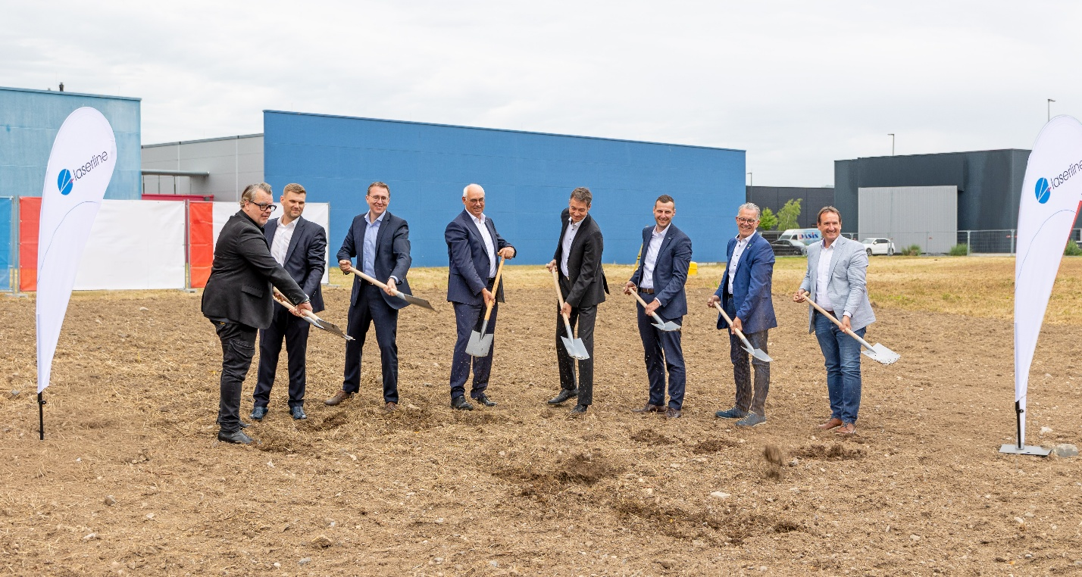
Image 1: Groundbreaking ceremony for the expansion of Laserline’s corporate headquarters; from left to right: Jens Ternes (Ternes Architekten), Viktor Freund (Köster Bau), Dr. Claus Narr, Dr. Christoph Ullmann, Volker Krause, Dr. Alexander Arndt (all managing directors of Laserline), Gerd Harner (mayor of the municipality of Mülheim-Kärlich), Thomas Przybylla (Mayor of the Weißenthurm Municipal Association). Image source: Laserline

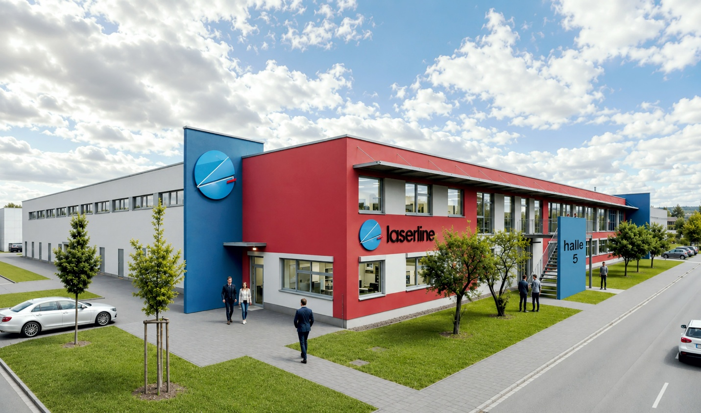
Image 2: This is what the expanded Laserline headquarters will look like in the future. Image source: Ternes Architekten

About Laserline:

Laserline GmbH, based in Mülheim-Kärlich near Koblenz, was founded in 1997. The company is a world leader in the development and manufacture of extremely efficient, modular diode laser systems at blue and infrared wavelengths. Laserline high-power diode lasers achieve output powers of up to 60 kW and an electrical efficiency (WPE) of over 56%. Based on decades of experience, Laserline develops customized laser solutions for industrial applications – including high-quality beam-shaping optics for the realization of variable spot geometries – and has established itself internationally as a reliable partner. More than 8,500 high-power diode lasers from Laserline are currently in use around the world, demonstrating their performance in a wide variety of processes and applications. The laser technology specialist currently employs around 440 people and has international subsidiaries in the USA, Mexico, Brazil, Japan, China, South Korea and India. Further information at https://www.laserline.com/en-int/

Contact Company:  Laserline GmbH  Stefan Aust  Fraunhofer Straße  D-56218 Mülheim-Kärlich  Tel. +49 (0) 2630 964-1440  Fax +49 (0) 2630 964-1018  Stefan.Aust@laserline.com  www.laserline.com | Contact Agency:  riba:businesstalk  Michael Beyrau  Klostergut Besselich  D-56182 Urbar/Koblenz  Tel. +49 (0)261-963 757-27  Fax +49 (0)261-963 757-11  mbeyrau@riba.eu  www.riba.eu

